

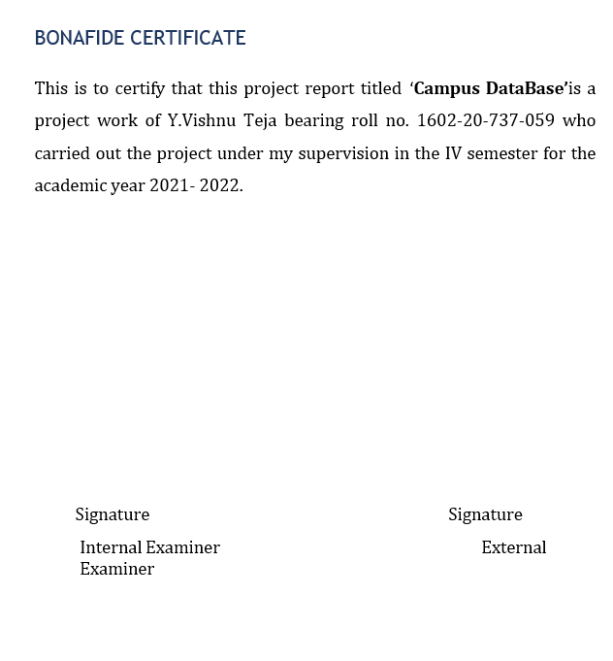

**ABSTRACT:**

In this project, we are creating a campus database, in which we are calculating

the percentage of parking utilized per block.

This project allows us to solve the problem that how much parking area is utilized per block in the campus. We can also know how many 2-wheeler are parked in the parking lot and also we can know the no. of 4-wheelers are parked.

**Requirement Analysis**

List of Tables:

* Campus
* Block
* Parking _slot
* Slot _type
* Calculates

**List of Attributes with their attributes**:

**Campus**

* College _id Number (5)
* College _name Varchar2(20)
* Address Varchar2(20)

**Block**

* Block _id varchar2(20)
* Block _name Varchar2(20)
* Total _ capacity Number (3)

**Parking _slot**

* College _id Number (5)
* Total _Capacity Number (5)

**Slot _type**

* 2-wheeler Number (5)
* 4-wheeler Number (5)
* Block _id varchar2(20)

**Calculates**

* Percentage Number (5)
* 2-wheeler Number (5)
* 4-wheeler Number (5)

**DESIGN**

Entity Relationship Diagram

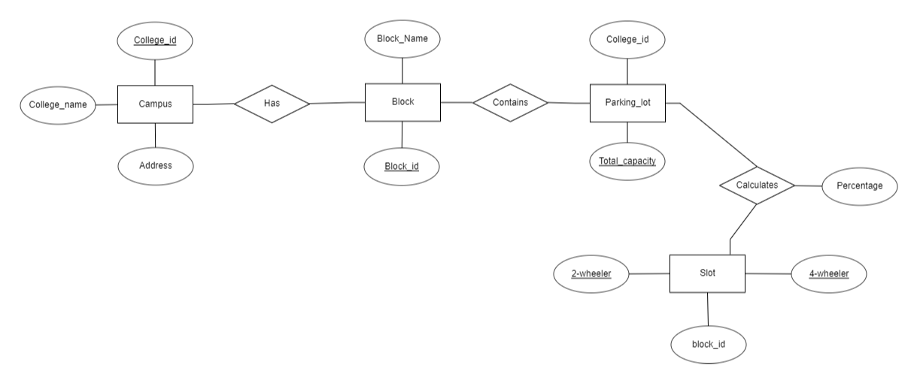

**DDL COMMANDS:**

1)

create table Campus(

College_id Number(5),

College_name varchar(20),

Address varchar(20));

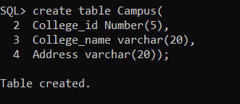

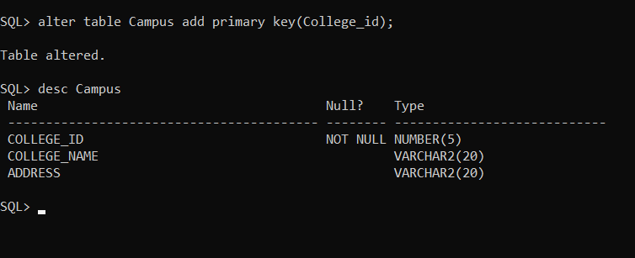

**2)**

create table Block(

2.Block_id varchar(5),

3. Block_name varchar(20));

SQL> alter table block add primary key(block_id);

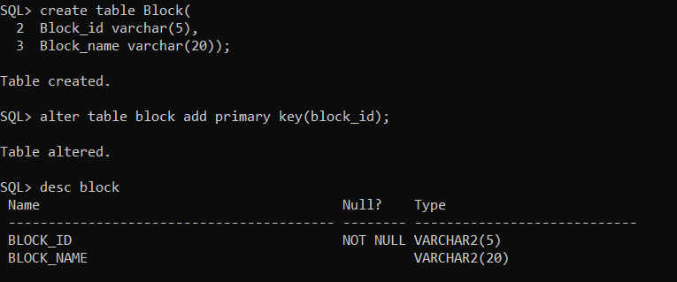

3)

create table parking_lot

2.(college_id Number(5),

3.Total_capacity Number(5));

SQL> alter table parking_lot

2.add primary key(total_capacity);

SQL> alter table parking_lot add foreign key(college_id) references campus;

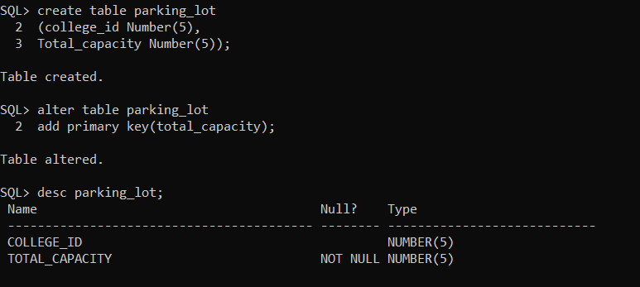



**4)**

create table slot

2.(two_wheeler Number(5),

3.four_wheeler number(5),

4.block_id varchar(5));

> alter table slot add foreign key(block_id) references block;

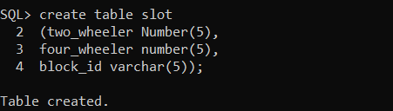

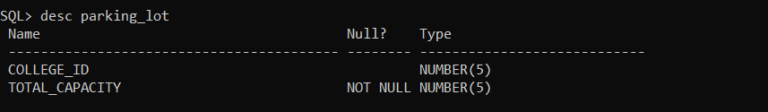

**5)**

create table calculates

2. (total_capacity number(5),

3. two_wheeler number(5),

4. four_wheeler number(5),

5. percentage float(5));

>>alter table calculates add foreign key(total_capacity) references parking_lot;

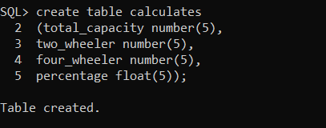

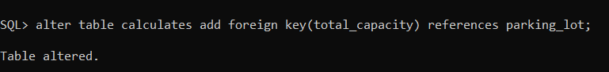

**DML OPERATIONS**:

1)Inserting values into Campus Table

insert into campus values(&college_id,'&college_name','&address');

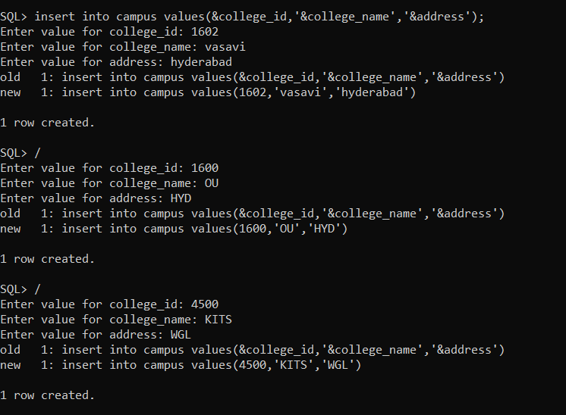

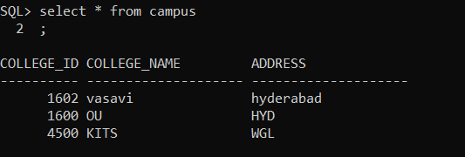

**2)Inserting values into Block Table**

insert into block values('&block_id','&block_name');

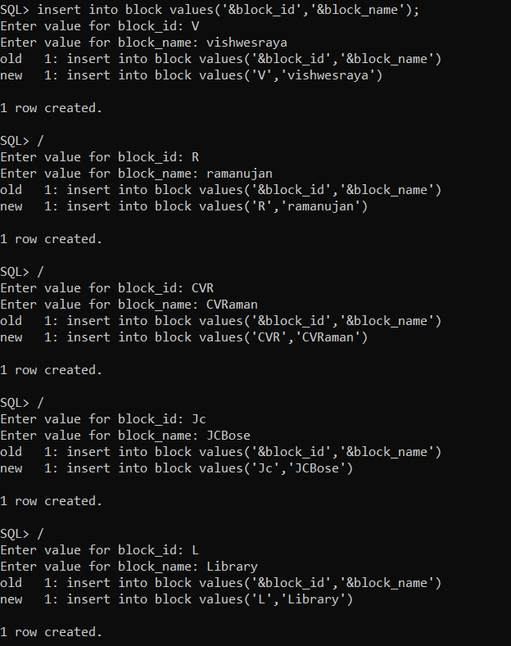

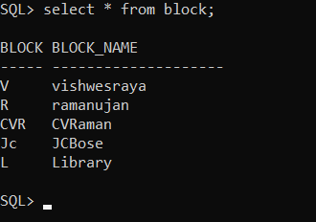

**3) Inserting values into Parking_lot:**

insert into parking_lot values(&college_id,&total_capacity);

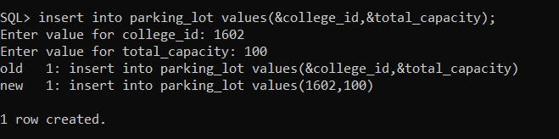

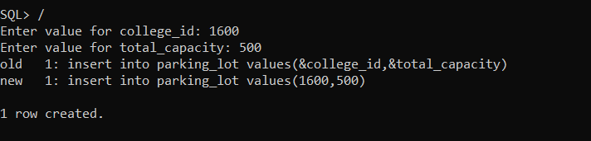

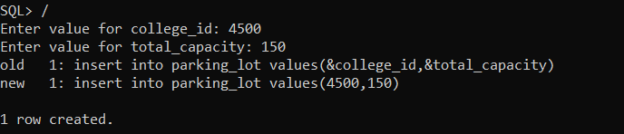

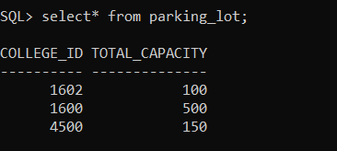

**4)Inserting values into Slot**

insert into slot values(&two_wheeler,&four_wheeler,'&Block_id');

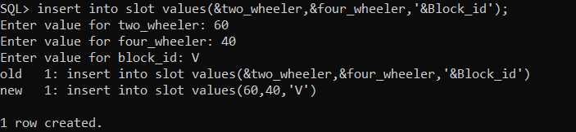

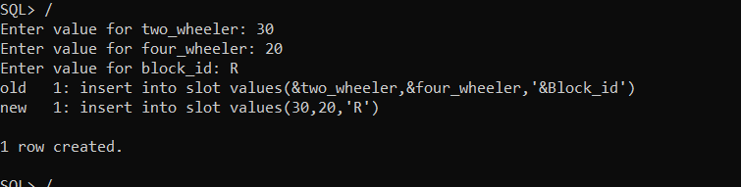

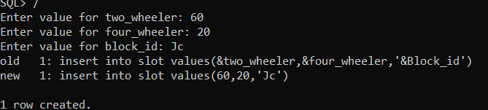

**Implementation:**

Front end programs and its connectivity Java Database Connectivity (JDBC) is an application programming interface (API) for the programming language Java, which defines how a client may access a database. It is a Java-based data access technology used for Java database connectivity. It is part of the Java Standard Edition platform, from Oracle Corporation. It provides methods to queryand update data in a database and is oriented towards relational databases.The connection to the database can be performed using Java programming (JDBC API) as:

public void connectToDB()

{

try

{

connection

=

DriverManager.getConnection("jdbc:oracle:thin:@localhost:1521:xe","vishnu","vasavi");

statement = connection.createStatement();

}

catch (SQLException connectException)

{

System.out.println(connectException.getMessage())

;

System.out.println(connectException.getSQLState()

);

System.out.println(connectException.getErrorCode());

System.exit(1);

}

}

Thus, the connection from Java to Oracle database is performed and therefore, can be used for updating tables in the database directly.

Program:

MainPage:

public class Campus extends javax.swing.JFrame {

public Campus() {

initComponents();

}

private void initComponents() {

jLabel1 = new javax.swing.JLabel();

jPanel1 = new javax.swing.JPanel();

jLabel4 = new javax.swing.JLabel();

jLabel2 = new javax.swing.JLabel();

jMenuBar1 = new javax.swing.JMenuBar();

jMenu1 = new javax.swing.JMenu();

c_insert = new javax.swing.JMenuItem();

C_update = new javax.swing.JMenuItem();

c_delete = new javax.swing.JMenuItem();

c_view = new javax.swing.JMenuItem();

jMenu2 = new javax.swing.JMenu();

Block_insert = new javax.swing.JMenuItem();

Block_update = new javax.swing.JMenuItem();

Block_delete = new javax.swing.JMenuItem();

Block_view = new javax.swing.JMenuItem();

jMenu4 = new javax.swing.JMenu();

s_insert = new javax.swing.JMenuItem();

slot_update = new javax.swing.JMenuItem();

s_View = new javax.swing.JMenuItem();

percent = new javax.swing.JMenu();

Percentage = new javax.swing.JMenuItem();

jLabel1.setFont(new java.awt.Font("Candara", 1, 24)); // NOI18N

jLabel1.setText(" Select from Menu Bar");

setDefaultCloseOperation(javax.swing.WindowConstants.EXIT_ON_CLOSE);

setTitle("MainPage");

jPanel1.setLayout(null);

jLabel4.setFont(new java.awt.Font("MS UI Gothic", 1, 18)); // NOI18N

jLabel4.setText("CAMPUS DATABASE FOR PARKING MANAGMENT\n");

jPanel1.add(jLabel4);

jLabel4.setBounds(190, 80, 430, 60);

jLabel2.setIcon(new javax.swing.ImageIcon("C:\\Users\\Y.VISHNU TEJA\\Downloads\\campus2_1.jpg")); // NOI18N

jPanel1.add(jLabel2);

jLabel2.setBounds(0, 0, 780, 400);

jMenu1.setText("Campus");

c_insert.setText("Insert");

c_insert.addActionListener(new java.awt.event.ActionListener() {

public void actionPerformed(java.awt.event.ActionEvent evt) {

c_insertActionPerformed(evt);

}

});

jMenu1.add(c_insert);

C_update.setText("Update");

C_update.addActionListener(new java.awt.event.ActionListener() {

public void actionPerformed(java.awt.event.ActionEvent evt) {

C_updateActionPerformed(evt);

}

});

jMenu1.add(C_update);

c_delete.setText("Delete");

c_delete.addActionListener(new java.awt.event.ActionListener() {

public void actionPerformed(java.awt.event.ActionEvent evt) {

c_deleteActionPerformed(evt);

}

});

jMenu1.add(c_delete);

c_view.setText("View");

c_view.addActionListener(new java.awt.event.ActionListener() {

public void actionPerformed(java.awt.event.ActionEvent evt) {

c_viewActionPerformed(evt);

}

});

jMenu1.add(c_view);

jMenuBar1.add(jMenu1);

jMenu2.setText("Block");

Block_insert.setText("Insert");

Block_insert.addActionListener(new java.awt.event.ActionListener() {

public void actionPerformed(java.awt.event.ActionEvent evt) {

Block_insertActionPerformed(evt);

}

});

jMenu2.add(Block_insert);

Block_update.setText("Update");

Block_update.addActionListener(new java.awt.event.ActionListener() {

public void actionPerformed(java.awt.event.ActionEvent evt) {

Block_updateActionPerformed(evt);

}

});

jMenu2.add(Block_update);

Block_delete.setText("Delete");

Block_delete.addActionListener(new java.awt.event.ActionListener() {

public void actionPerformed(java.awt.event.ActionEvent evt) {

Block_deleteActionPerformed(evt);

}

});

jMenu2.add(Block_delete);

Block_view.setText("View");

Block_view.addActionListener(new java.awt.event.ActionListener() {

public void actionPerformed(java.awt.event.ActionEvent evt) {

Block_viewActionPerformed(evt);

}

});

jMenu2.add(Block_view);

jMenuBar1.add(jMenu2);

jMenu4.setText("Slot");

jMenu4.addActionListener(new java.awt.event.ActionListener() {

public void actionPerformed(java.awt.event.ActionEvent evt) {

jMenu4ActionPerformed(evt);

}

});

s_insert.setText("Insert");

s_insert.addActionListener(new java.awt.event.ActionListener() {

public void actionPerformed(java.awt.event.ActionEvent evt) {

s_insertActionPerformed(evt);

}

});

jMenu4.add(s_insert);

slot_update.setText("update");

slot_update.addActionListener(new java.awt.event.ActionListener() {

public void actionPerformed(java.awt.event.ActionEvent evt) {

slot_updateActionPerformed(evt);

}

});

jMenu4.add(slot_update);

s_View.setText("View");

s_View.addActionListener(new java.awt.event.ActionListener() {

public void actionPerformed(java.awt.event.ActionEvent evt) {

s_ViewActionPerformed(evt);

}

});

jMenu4.add(s_View);

jMenuBar1.add(jMenu4);

percent.setText("Percentage");

Percentage.setText("Percentage");

Percentage.addActionListener(new java.awt.event.ActionListener() {

public void actionPerformed(java.awt.event.ActionEvent evt) {

PercentageActionPerformed(evt);

}

});

percent.add(Percentage);

jMenuBar1.add(percent);

setJMenuBar(jMenuBar1);

javax.swing.GroupLayout layout = new javax.swing.GroupLayout(getContentPane());

getContentPane().setLayout(layout);

layout.setHorizontalGroup(

layout.createParallelGroup(javax.swing.GroupLayout.Alignment.LEADING)

.addComponent(jPanel1, javax.swing.GroupLayout.DEFAULT_SIZE, 787, Short.MAX_VALUE)

);

layout.setVerticalGroup(

layout.createParallelGroup(javax.swing.GroupLayout.Alignment.LEADING)

.addGroup(layout.createSequentialGroup()

.addContainerGap()

.addComponent(jPanel1, javax.swing.GroupLayout.DEFAULT_SIZE, 417, Short.MAX_VALUE))

);

pack();

}// </editor-fold>

private void c_insertActionPerformed(java.awt.event.ActionEvent evt) {

// TODO add your handling code here:

Campus_insert ci=new Campus_insert();

ci.show();

dispose();

}

private void Block_updateActionPerformed(java.awt.event.ActionEvent evt) {

// TODO add your handling code here:

Block_Update bu=new Block_Update();

bu.show();

dispose();

}

private void Block_insertActionPerformed(java.awt.event.ActionEvent evt) {

// TODO add your handling code here:

Block_insert bi=new Block_insert();

bi.show();

dispose();

}

private void C_updateActionPerformed(java.awt.event.ActionEvent evt) {

// TODO add your handling code here:

Campus_Update cu=new Campus_Update();

cu.show();

dispose();

}

private void c_deleteActionPerformed(java.awt.event.ActionEvent evt) {

// TODO add your handling code here:

Campus_Delete cd=new Campus_Delete();

cd.show();

dispose();

}

private void c_viewActionPerformed(java.awt.event.ActionEvent evt) {

// TODO add your handling code here:

Campus_view cv=new Campus_view();

cv.show();

dispose();

}

private void PercentageActionPerformed(java.awt.event.ActionEvent evt) {

// TODO add your handling code here:

Percentage p=new Percentage();

p.show();

dispose();

}

private void Block_viewActionPerformed(java.awt.event.ActionEvent evt) {

// TODO add your handling code here:

Block_View b_v=new Block_View();

b_v.show();

dispose();

}

private void s_insertActionPerformed(java.awt.event.ActionEvent evt) {

// TODO add your handling code here:

Slot_insert si=new Slot_insert();

si.show();

dispose();

}

private void slot_updateActionPerformed(java.awt.event.ActionEvent evt) {

// TODO add your handling code here:

Slot_update su=new Slot_update();

su.show();

dispose();

}

private void s_ViewActionPerformed(java.awt.event.ActionEvent evt) {

// TODO add your handling code here:

Slot_view sv=new Slot_view();

sv.show();

dispose();

}

private void Block_deleteActionPerformed(java.awt.event.ActionEvent evt) {

// TODO add your handling code here:

Block_Delete b_d=new Block_Delete();

b_d.show();

dispose();

}

public static void main(String args[]) {

try {

for (javax.swing.UIManager.LookAndFeelInfo info : javax.swing.UIManager.getInstalledLookAndFeels()) {

if ("com.formdev.flatlaf.FlatDarkLaf".equals(info.getName())) {

javax.swing.UIManager.setLookAndFeel(info.getClassName());

break;

}

}

} catch (ClassNotFoundException ex) {

java.util.logging.Logger.getLogger(Campus.class.getName()).log(java.util.logging.Level.SEVERE, null, ex);

} catch (InstantiationException ex) {

java.util.logging.Logger.getLogger(Campus.class.getName()).log(java.util.logging.Level.SEVERE, null, ex);

} catch (IllegalAccessException ex) {

java.util.logging.Logger.getLogger(Campus.class.getName()).log(java.util.logging.Level.SEVERE, null, ex);

} catch (javax.swing.UnsupportedLookAndFeelException ex) {

java.util.logging.Logger.getLogger(Campus.class.getName()).log(java.util.logging.Level.SEVERE, null, ex);

}

//</editor-fold>

/* Create and display the form */

java.awt.EventQueue.invokeLater(new Runnable() {

public void run() {

new Campus().setVisible(true);

}

});

}

// Variables declaration - do not modify

private javax.swing.JMenuItem Block_delete;

private javax.swing.JMenuItem Block_insert;

private javax.swing.JMenuItem Block_update;

private javax.swing.JMenuItem Block_view;

private javax.swing.JMenuItem C_update;

private javax.swing.JMenuItem Percentage;

private javax.swing.JMenuItem c_delete;

private javax.swing.JMenuItem c_insert;

private javax.swing.JMenuItem c_view;

private javax.swing.JLabel jLabel1;

private javax.swing.JLabel jLabel2;

private javax.swing.JLabel jLabel4;

private javax.swing.JMenu jMenu1;

private javax.swing.JMenu jMenu2;

private javax.swing.JMenu jMenu4;

private javax.swing.JMenuBar jMenuBar1;

private javax.swing.JPanel jPanel1;

private javax.swing.JMenu percent;

private javax.swing.JMenuItem s_View;

private javax.swing.JMenuItem s_insert;

private javax.swing.JMenuItem slot_update;

// End of variables declaration

}

**Table: Campus**

import java.sql.Connection;

import java.sql.DriverManager;

import java.sql.*;

import javax.swing.JOptionPane;

import javax.swing.JScrollPane;

import javax.swing.JTable;

import javax.swing.table.DefaultTableModel;

public class Campus_insert extends javax.swing.JFrame {

public Campus_insert() {

initComponents();

}

private void initComponents() {

jLabel1 = new javax.swing.JLabel();

jLabel2 = new javax.swing.JLabel();

jLabel3 = new javax.swing.JLabel();

JTF_Collegeid = new javax.swing.JTextField();

JTF_College_Name = new javax.swing.JTextField();

JTF_address = new javax.swing.JTextField();

jButton1 = new javax.swing.JButton();

jScrollPane1 = new javax.swing.JScrollPane();

Campus_view = new javax.swing.JTable();

JB_View = new javax.swing.JButton();

jLabel4 = new javax.swing.JLabel();

CI_back = new javax.swing.JButton();

jMenuBar1 = new javax.swing.JMenuBar();

jMenu1 = new javax.swing.JMenu();

Campus_insert = new javax.swing.JMenuItem();

Campus_update = new javax.swing.JMenuItem();

Campus_delete = new javax.swing.JMenuItem();

Campus_View = new javax.swing.JMenuItem();

jMenu2 = new javax.swing.JMenu();

Block_insert = new javax.swing.JMenuItem();

Campus_Update = new javax.swing.JMenuItem();

Block_Delete = new javax.swing.JMenuItem();

Block_view = new javax.swing.JMenuItem();

jMenu3 = new javax.swing.JMenu();

Insert = new javax.swing.JMenuItem();

PL_update = new javax.swing.JMenuItem();

PL_delete = new javax.swing.JMenuItem();

PL_view = new javax.swing.JMenuItem();

Slot_menu = new javax.swing.JMenu();

jMenuItem13 = new javax.swing.JMenuItem();

jMenuItem14 = new javax.swing.JMenuItem();

jMenuItem15 = new javax.swing.JMenuItem();

setDefaultCloseOperation(javax.swing.WindowConstants.EXIT_ON_CLOSE);

setTitle("Insert Campus Details");

setBackground(new java.awt.Color(3, 252, 236));

jLabel1.setFont(new java.awt.Font("Segoe UI Black", 0, 14)); // NOI18N

jLabel1.setText("College Id :");

jLabel2.setFont(new java.awt.Font("Segoe UI Black", 0, 14)); // NOI18N

jLabel2.setText("College Name :");

jLabel3.setFont(new java.awt.Font("Segoe UI Black", 0, 14)); // NOI18N

jLabel3.setText("Address :");

jButton1.setText("INSERT");

jButton1.addActionListener(new java.awt.event.ActionListener() {

public void actionPerformed(java.awt.event.ActionEvent evt) {

jButton1ActionPerformed(evt);

}

});

Campus_view.setModel(new javax.swing.table.DefaultTableModel(

new Object [][] {

},

new String [] {

"College Name", "Address", "College Id "

}

) {

Class[] types = new Class [] {

java.lang.String.class, java.lang.String.class, java.lang.Integer.class

};

boolean[] canEdit = new boolean [] {

false, false, false

};

public Class getColumnClass(int columnIndex) {

return types [columnIndex];

}

public boolean isCellEditable(int rowIndex, int columnIndex) {

return canEdit [columnIndex];

}

});

jScrollPane1.setViewportView(Campus_view);

if (Campus_view.getColumnModel().getColumnCount() > 0) {

Campus_view.getColumnModel().getColumn(0).setResizable(false);

Campus_view.getColumnModel().getColumn(1).setResizable(false);

Campus_view.getColumnModel().getColumn(2).setResizable(false);

}

JB_View.setText("View");

JB_View.addActionListener(new java.awt.event.ActionListener() {

public void actionPerformed(java.awt.event.ActionEvent evt) {

JB_ViewActionPerformed(evt);

}

});

jLabel4.setFont(new java.awt.Font("Segoe UI Black", 0, 14)); // NOI18N

jLabel4.setText("Insert the College Details");

jLabel4.setToolTipText("");

CI_back.setText("Back");

CI_back.addActionListener(new java.awt.event.ActionListener() {

public void actionPerformed(java.awt.event.ActionEvent evt) {

CI_backActionPerformed(evt);

}

});

jMenu1.setText("Campus");

Campus_insert.setText("Insert");

Campus_insert.addActionListener(new java.awt.event.ActionListener() {

public void actionPerformed(java.awt.event.ActionEvent evt) {

Campus_insertActionPerformed(evt);

}

});

jMenu1.add(Campus_insert);

Campus_update.setText("Update");

Campus_update.addActionListener(new java.awt.event.ActionListener() {

public void actionPerformed(java.awt.event.ActionEvent evt) {

Campus_updateActionPerformed(evt);

}

});

jMenu1.add(Campus_update);

Campus_delete.setText("Delete");

Campus_delete.addActionListener(new java.awt.event.ActionListener() {

public void actionPerformed(java.awt.event.ActionEvent evt) {

Campus_deleteActionPerformed(evt);

}

});

jMenu1.add(Campus_delete);

Campus_View.setText("View");

Campus_View.addActionListener(new java.awt.event.ActionListener() {

public void actionPerformed(java.awt.event.ActionEvent evt) {

Campus_ViewActionPerformed(evt);

}

});

jMenu1.add(Campus_View);

jMenuBar1.add(jMenu1);

jMenu2.setText("Block");

Block_insert.setText("Insert");

Block_insert.addActionListener(new java.awt.event.ActionListener() {

public void actionPerformed(java.awt.event.ActionEvent evt) {

Block_insertActionPerformed(evt);

}

});

jMenu2.add(Block_insert);

Campus_Update.setText("Update");

jMenu2.add(Campus_Update);

Block_Delete.setText("Delete");

jMenu2.add(Block_Delete);

Block_view.setText("View");

jMenu2.add(Block_view);

jMenuBar1.add(jMenu2);

jMenu3.setText("Parking_lot");

Insert.setText("Insert");

jMenu3.add(Insert);

PL_update.setText("Update");

jMenu3.add(PL_update);

PL_delete.setText("Delete");

jMenu3.add(PL_delete);

PL_view.setText("View");

jMenu3.add(PL_view);

jMenuBar1.add(jMenu3);

Slot_menu.setText("Slot");

jMenuItem13.setText("Insert");

Slot_menu.add(jMenuItem13);

jMenuItem14.setText("Update");

jMenuItem14.addActionListener(new java.awt.event.ActionListener() {

public void actionPerformed(java.awt.event.ActionEvent evt) {

jMenuItem14ActionPerformed(evt);

}

});

Slot_menu.add(jMenuItem14);

jMenuItem15.setText("jMenuItem15");

Slot_menu.add(jMenuItem15);

jMenuBar1.add(Slot_menu);

setJMenuBar(jMenuBar1);

javax.swing.GroupLayout layout = new javax.swing.GroupLayout(getContentPane());

getContentPane().setLayout(layout);

layout.setHorizontalGroup(

layout.createParallelGroup(javax.swing.GroupLayout.Alignment.LEADING)

.addGroup(layout.createSequentialGroup()

.addGap(96, 96, 96)

.addComponent(jButton1, javax.swing.GroupLayout.PREFERRED_SIZE, 120, javax.swing.GroupLayout.PREFERRED_SIZE)

.addPreferredGap(javax.swing.LayoutStyle.ComponentPlacement.RELATED, javax.swing.GroupLayout.DEFAULT_SIZE, Short.MAX_VALUE)

.addComponent(JB_View, javax.swing.GroupLayout.PREFERRED_SIZE, 112, javax.swing.GroupLayout.PREFERRED_SIZE)

.addGap(165, 165, 165))

.addGroup(layout.createSequentialGroup()

.addContainerGap(50, Short.MAX_VALUE)

.addGroup(layout.createParallelGroup(javax.swing.GroupLayout.Alignment.LEADING, false)

.addComponent(jLabel2, javax.swing.GroupLayout.DEFAULT_SIZE, javax.swing.GroupLayout.DEFAULT_SIZE, Short.MAX_VALUE)

.addComponent(jLabel3)

.addComponent(jLabel1, javax.swing.GroupLayout.DEFAULT_SIZE, javax.swing.GroupLayout.DEFAULT_SIZE, Short.MAX_VALUE))

.addGap(30, 30, 30)

.addGroup(layout.createParallelGroup(javax.swing.GroupLayout.Alignment.LEADING, false)

.addComponent(JTF_Collegeid)

.addComponent(JTF_College_Name)

.addComponent(JTF_address, javax.swing.GroupLayout.DEFAULT_SIZE, 113, Short.MAX_VALUE))

.addGap(90, 90, 90)

.addComponent(jScrollPane1, javax.swing.GroupLayout.PREFERRED_SIZE, 368, javax.swing.GroupLayout.PREFERRED_SIZE)

.addGap(25, 25, 25))

.addGroup(layout.createSequentialGroup()

.addContainerGap()

.addComponent(CI_back)

.addGap(75, 75, 75)

.addComponent(jLabel4, javax.swing.GroupLayout.PREFERRED_SIZE, 242, javax.swing.GroupLayout.PREFERRED_SIZE)

.addContainerGap(javax.swing.GroupLayout.DEFAULT_SIZE, Short.MAX_VALUE))

);

layout.setVerticalGroup(

layout.createParallelGroup(javax.swing.GroupLayout.Alignment.LEADING)

.addGroup(layout.createSequentialGroup()

.addGap(9, 9, 9)

.addGroup(layout.createParallelGroup(javax.swing.GroupLayout.Alignment.BASELINE)

.addComponent(jLabel4, javax.swing.GroupLayout.PREFERRED_SIZE, 45, javax.swing.GroupLayout.PREFERRED_SIZE)

.addComponent(CI_back, javax.swing.GroupLayout.PREFERRED_SIZE, 32, javax.swing.GroupLayout.PREFERRED_SIZE))

.addGap(28, 28, 28)

.addGroup(layout.createParallelGroup(javax.swing.GroupLayout.Alignment.LEADING)

.addGroup(layout.createSequentialGroup()

.addGroup(layout.createParallelGroup(javax.swing.GroupLayout.Alignment.BASELINE)

.addComponent(jLabel1, javax.swing.GroupLayout.PREFERRED_SIZE, 36, javax.swing.GroupLayout.PREFERRED_SIZE)

.addComponent(JTF_Collegeid, javax.swing.GroupLayout.PREFERRED_SIZE, javax.swing.GroupLayout.DEFAULT_SIZE, javax.swing.GroupLayout.PREFERRED_SIZE))

.addPreferredGap(javax.swing.LayoutStyle.ComponentPlacement.UNRELATED)

.addGroup(layout.createParallelGroup(javax.swing.GroupLayout.Alignment.BASELINE)

.addComponent(jLabel2, javax.swing.GroupLayout.PREFERRED_SIZE, 38, javax.swing.GroupLayout.PREFERRED_SIZE)

.addComponent(JTF_College_Name, javax.swing.GroupLayout.PREFERRED_SIZE, javax.swing.GroupLayout.DEFAULT_SIZE, javax.swing.GroupLayout.PREFERRED_SIZE))

.addPreferredGap(javax.swing.LayoutStyle.ComponentPlacement.UNRELATED)

.addGroup(layout.createParallelGroup(javax.swing.GroupLayout.Alignment.BASELINE)

.addComponent(jLabel3, javax.swing.GroupLayout.PREFERRED_SIZE, 41, javax.swing.GroupLayout.PREFERRED_SIZE)

.addComponent(JTF_address, javax.swing.GroupLayout.PREFERRED_SIZE, javax.swing.GroupLayout.DEFAULT_SIZE, javax.swing.GroupLayout.PREFERRED_SIZE))

.addGap(45, 45, 45))

.addGroup(javax.swing.GroupLayout.Alignment.TRAILING, layout.createSequentialGroup()

.addGap(1, 1, 1)

.addComponent(jScrollPane1, javax.swing.GroupLayout.PREFERRED_SIZE, 166, javax.swing.GroupLayout.PREFERRED_SIZE)

.addGap(29, 29, 29)))

.addGroup(layout.createParallelGroup(javax.swing.GroupLayout.Alignment.BASELINE)

.addComponent(JB_View, javax.swing.GroupLayout.PREFERRED_SIZE, 37, javax.swing.GroupLayout.PREFERRED_SIZE)

.addComponent(jButton1, javax.swing.GroupLayout.PREFERRED_SIZE, 37, javax.swing.GroupLayout.PREFERRED_SIZE))

.addGap(55, 55, 55))

);

pack();

}

private void jButton1ActionPerformed(java.awt.event.ActionEvent evt) {

// TODO add your handling code here:

Connection con =null;

try

{

Driver myDriver = new oracle.jdbc.driver.OracleDriver();

DriverManager.registerDriver( myDriver );

con = DriverManager.getConnection("jdbc:oracle:thin:@localhost:1521:XE", "vishnu", "vasavi");

Statement stmt = con.createStatement();

String query= "INSERT INTO campus VALUES(" + JTF_Collegeid.getText() + ","+ "'" +JTF_College_Name.getText() +"',"+ "'"+JTF_address.getText() +"')";

int i = stmt.executeUpdate(query);

JOptionPane.showMessageDialog(this, "Inserted Suucesfully !!!");

System .out.println("Inserted ....");

stmt.close();

con.close();

}catch(Exception e){

System.out.println(e);

}

}

private void JB_ViewActionPerformed(java.awt.event.ActionEvent evt) {

// TODO add your handling code here:

Connection con =null;

try

{

Driver myDriver = new oracle.jdbc.driver.OracleDriver();

DriverManager.registerDriver( myDriver );

con = DriverManager.getConnection("jdbc:oracle:thin:@localhost:1521:XE", "vishnu", "vasavi");

Statement stmt = con.createStatement();

ResultSet Rs = stmt.executeQuery("select * from Campus");

DefaultTableModel model = (DefaultTableModel)Campus_view.getModel();

while(Rs.next()){

model.addRow(new Object[]{Rs.getInt("College_id"), Rs.getString("College_Name"),Rs.getString("Address")});

}

System.out.println("Values retrived");

//stmt.close();

con.close();

}catch(Exception e){

System.out.println(e);

}

}

private void jMenuItem14ActionPerformed(java.awt.event.ActionEvent evt) {

// TODO add your handling code here:

}

private void Campus_insertActionPerformed(java.awt.event.ActionEvent evt) {

// TODO add your handling code here:

Campus_insert ci=new Campus_insert();

ci.show();

dispose();

}

private void Campus_updateActionPerformed(java.awt.event.ActionEvent evt) {

// TODO add your handling code here:

Campus_Update cu=new Campus_Update();

cu.show();

dispose();

}

private void Campus_deleteActionPerformed(java.awt.event.ActionEvent evt) {

// TODO add your handling code here:

Campus_Delete cd= new Campus_Delete();

cd.show();

dispose();

}

private void Campus_ViewActionPerformed(java.awt.event.ActionEvent evt) {

// TODO add your handling code here:

Campus_view cv=new Campus_view();

cv.show();

dispose();

}

private void Block_insertActionPerformed(java.awt.event.ActionEvent evt) {

// TODO add your handling code here:

Block_insert bi=new Block_insert();

bi.show();

dispose();

}

private void CI_backActionPerformed(java.awt.event.ActionEvent evt) {

// TODO add your handling code here:

Campus c_b=new Campus();

c_b.show();

dispose();

}

public static void main(String args[]) {

try {

for (javax.swing.UIManager.LookAndFeelInfo info : javax.swing.UIManager.getInstalledLookAndFeels()) {

if ("com.formdev.flatlaf.FlatDarkLaf".equals(info.getName())) {

javax.swing.UIManager.setLookAndFeel(info.getClassName());

break;

}

}

} catch (ClassNotFoundException ex) {

java.util.logging.Logger.getLogger(Campus_insert.class.getName()).log(java.util.logging.Level.SEVERE, null, ex);

} catch (InstantiationException ex) {

java.util.logging.Logger.getLogger(Campus_insert.class.getName()).log(java.util.logging.Level.SEVERE, null, ex);

} catch (IllegalAccessException ex) {

java.util.logging.Logger.getLogger(Campus_insert.class.getName()).log(java.util.logging.Level.SEVERE, null, ex);

} catch (javax.swing.UnsupportedLookAndFeelException ex) {

java.util.logging.Logger.getLogger(Campus_insert.class.getName()).log(java.util.logging.Level.SEVERE, null, ex);

}

java.awt.EventQueue.invokeLater(new Runnable() {

public void run() {

new Campus_insert().setVisible(true);

}

});

}

// Variables declaration - do not modify

private javax.swing.JMenuItem Block_Delete;

private javax.swing.JMenuItem Block_insert;

private javax.swing.JMenuItem Block_view;

private javax.swing.JButton CI_back;

private javax.swing.JMenuItem Campus_Update;

private javax.swing.JMenuItem Campus_View;

private javax.swing.JMenuItem Campus_delete;

private javax.swing.JMenuItem Campus_insert;

private javax.swing.JMenuItem Campus_update;

private javax.swing.JTable Campus_view;

private javax.swing.JMenuItem Insert;

private javax.swing.JButton JB_View;

private javax.swing.JTextField JTF_College_Name;

private javax.swing.JTextField JTF_Collegeid;

private javax.swing.JTextField JTF_address;

private javax.swing.JMenuItem PL_delete;

private javax.swing.JMenuItem PL_update;

private javax.swing.JMenuItem PL_view;

private javax.swing.JMenu Slot_menu;

private javax.swing.JButton jButton1;

private javax.swing.JLabel jLabel1;

private javax.swing.JLabel jLabel2;

private javax.swing.JLabel jLabel3;

private javax.swing.JLabel jLabel4;

private javax.swing.JMenu jMenu1;

private javax.swing.JMenu jMenu2;

private javax.swing.JMenu jMenu3;

private javax.swing.JMenuBar jMenuBar1;

private javax.swing.JMenuItem jMenuItem13;

private javax.swing.JMenuItem jMenuItem14;

private javax.swing.JMenuItem jMenuItem15;

private javax.swing.JScrollPane jScrollPane1;

// End of variables declaration

}

**Campus Update:**

import java.sql.Connection;

import java.sql.Driver;

import java.sql.DriverManager;

import java.sql.PreparedStatement;

import java.sql.ResultSet;

import java.sql.Statement;

import javax.swing.JOptionPane;

import javax.swing.table.DefaultTableModel;

public class Campus_Update extends javax.swing.JFrame {

public Campus_Update() {

initComponents();

}

// <editor-fold defaultstate="collapsed" desc="Generated Code">

private void initComponents() {

jLabel2 = new javax.swing.JLabel();

jLabel3 = new javax.swing.JLabel();

JTF_collegeid = new javax.swing.JTextField();

JTF_college_name = new javax.swing.JTextField();

JTF_address = new javax.swing.JTextField();

jButton1 = new javax.swing.JButton();

jLabel1 = new javax.swing.JLabel();

jLabel4 = new javax.swing.JLabel();

jScrollPane1 = new javax.swing.JScrollPane();

jTable1 = new javax.swing.JTable();

JB_C_V = new javax.swing.JButton();

jButton3 = new javax.swing.JButton();

ComboBox1 = new javax.swing.JComboBox<>();

jMenuBar1 = new javax.swing.JMenuBar();

jMenu1 = new javax.swing.JMenu();

jMenu2 = new javax.swing.JMenu();

setDefaultCloseOperation(javax.swing.WindowConstants.EXIT_ON_CLOSE);

setTitle("Update College Details");

jLabel2.setFont(new java.awt.Font("Segoe UI Black", 0, 14)); // NOI18N

jLabel2.setText("College Name :");

jLabel3.setFont(new java.awt.Font("Segoe UI Black", 0, 14)); // NOI18N

jLabel3.setText("Address :");

JTF_college_name.addActionListener(new java.awt.event.ActionListener() {

public void actionPerformed(java.awt.event.ActionEvent evt) {

JTF_college_nameActionPerformed(evt);

}

});

JTF_address.addActionListener(new java.awt.event.ActionListener() {

public void actionPerformed(java.awt.event.ActionEvent evt) {

JTF_addressActionPerformed(evt);

}

});

jButton1.setText("Update");

jButton1.addActionListener(new java.awt.event.ActionListener() {

public void actionPerformed(java.awt.event.ActionEvent evt) {

jButton1ActionPerformed(evt);

}

});

jLabel1.setFont(new java.awt.Font("Segoe UI Black", 0, 14)); // NOI18N

jLabel1.setText("College Id :");

jLabel4.setFont(new java.awt.Font("Segoe UI Black", 0, 14)); // NOI18N

jLabel4.setText("Update the College Details ");

jTable1.setModel(new javax.swing.table.DefaultTableModel(

new Object [][] {

},

new String [] {

"College Id", "CollegeName", "Address"

}

) {

Class[] types = new Class [] {

java.lang.Integer.class, java.lang.String.class, java.lang.String.class

};

public Class getColumnClass(int columnIndex) {

return types [columnIndex];

}

});

jScrollPane1.setViewportView(jTable1);

JB_C_V.setText("View");

JB_C_V.addActionListener(new java.awt.event.ActionListener() {

public void actionPerformed(java.awt.event.ActionEvent evt) {

JB_C_VActionPerformed(evt);

}

});

jButton3.setText("Back");

jButton3.addActionListener(new java.awt.event.ActionListener() {

public void actionPerformed(java.awt.event.ActionEvent evt) {

jButton3ActionPerformed(evt);

}

});

ComboBox1.setModel(new javax.swing.DefaultComboBoxModel<>(new String[] { "1602 -VCE", "1600- OU", "4500-KITS", " " }));

ComboBox1.addActionListener(new java.awt.event.ActionListener() {

public void actionPerformed(java.awt.event.ActionEvent evt) {

ComboBox1ActionPerformed(evt);

}

});

jMenu1.setText("File");

jMenuBar1.add(jMenu1);

jMenu2.setText("Edit");

jMenuBar1.add(jMenu2);

setJMenuBar(jMenuBar1);

javax.swing.GroupLayout layout = new javax.swing.GroupLayout(getContentPane());

getContentPane().setLayout(layout);

layout.setHorizontalGroup(

layout.createParallelGroup(javax.swing.GroupLayout.Alignment.LEADING)

.addGroup(layout.createSequentialGroup()

.addGroup(layout.createParallelGroup(javax.swing.GroupLayout.Alignment.LEADING)

.addGroup(layout.createSequentialGroup()

.addGroup(layout.createParallelGroup(javax.swing.GroupLayout.Alignment.LEADING)

.addGroup(layout.createSequentialGroup()

.addGap(117, 117, 117)

.addComponent(jButton1, javax.swing.GroupLayout.PREFERRED_SIZE, 120, javax.swing.GroupLayout.PREFERRED_SIZE))

.addGroup(layout.createSequentialGroup()

.addGap(42, 42, 42)

.addGroup(layout.createParallelGroup(javax.swing.GroupLayout.Alignment.LEADING)

.addGroup(layout.createSequentialGroup()

.addComponent(jLabel3)

.addPreferredGap(javax.swing.LayoutStyle.ComponentPlacement.RELATED)

.addComponent(JTF_address, javax.swing.GroupLayout.PREFERRED_SIZE, 178, javax.swing.GroupLayout.PREFERRED_SIZE))

.addComponent(jLabel2)

.addGroup(layout.createSequentialGroup()

.addComponent(jLabel1, javax.swing.GroupLayout.PREFERRED_SIZE, 111, javax.swing.GroupLayout.PREFERRED_SIZE)

.addGap(29, 29, 29)

.addComponent(JTF_collegeid, javax.swing.GroupLayout.PREFERRED_SIZE, 178, javax.swing.GroupLayout.PREFERRED_SIZE))

.addGroup(layout.createSequentialGroup()

.addGap(114, 114, 114)

.addComponent(JTF_college_name, javax.swing.GroupLayout.PREFERRED_SIZE, 178, javax.swing.GroupLayout.PREFERRED_SIZE))))

.addGroup(javax.swing.GroupLayout.Alignment.TRAILING, layout.createSequentialGroup()

.addContainerGap()

.addComponent(ComboBox1, javax.swing.GroupLayout.PREFERRED_SIZE, 178, javax.swing.GroupLayout.PREFERRED_SIZE)))

.addGap(44, 44, 44)

.addGroup(layout.createParallelGroup(javax.swing.GroupLayout.Alignment.LEADING)

.addComponent(jScrollPane1, javax.swing.GroupLayout.PREFERRED_SIZE, 327, javax.swing.GroupLayout.PREFERRED_SIZE)

.addGroup(javax.swing.GroupLayout.Alignment.TRAILING, layout.createSequentialGroup()

.addComponent(JB_C_V)

.addGap(142, 142, 142))))

.addGroup(layout.createSequentialGroup()

.addGap(16, 16, 16)

.addComponent(jButton3)

.addGap(129, 129, 129)

.addComponent(jLabel4, javax.swing.GroupLayout.PREFERRED_SIZE, 212, javax.swing.GroupLayout.PREFERRED_SIZE)))

.addContainerGap(65, Short.MAX_VALUE))

);

layout.setVerticalGroup(

layout.createParallelGroup(javax.swing.GroupLayout.Alignment.LEADING)

.addGroup(layout.createSequentialGroup()

.addContainerGap()

.addGroup(layout.createParallelGroup(javax.swing.GroupLayout.Alignment.LEADING)

.addComponent(jLabel4, javax.swing.GroupLayout.PREFERRED_SIZE, 48, javax.swing.GroupLayout.PREFERRED_SIZE)

.addComponent(jButton3, javax.swing.GroupLayout.Alignment.TRAILING))

.addGroup(layout.createParallelGroup(javax.swing.GroupLayout.Alignment.LEADING)

.addGroup(layout.createSequentialGroup()

.addGap(12, 12, 12)

.addComponent(jScrollPane1, javax.swing.GroupLayout.PREFERRED_SIZE, 215, javax.swing.GroupLayout.PREFERRED_SIZE)

.addGroup(layout.createParallelGroup(javax.swing.GroupLayout.Alignment.LEADING)

.addGroup(layout.createSequentialGroup()

.addPreferredGap(javax.swing.LayoutStyle.ComponentPlacement.RELATED)

.addComponent(jButton1, javax.swing.GroupLayout.PREFERRED_SIZE, 37, javax.swing.GroupLayout.PREFERRED_SIZE))

.addGroup(layout.createSequentialGroup()

.addGap(27, 27, 27)

.addComponent(JB_C_V, javax.swing.GroupLayout.PREFERRED_SIZE, 35, javax.swing.GroupLayout.PREFERRED_SIZE))))

.addGroup(layout.createSequentialGroup()

.addGroup(layout.createParallelGroup(javax.swing.GroupLayout.Alignment.LEADING)

.addGroup(layout.createSequentialGroup()

.addGap(7, 7, 7)

.addComponent(jLabel1, javax.swing.GroupLayout.PREFERRED_SIZE, 36, javax.swing.GroupLayout.PREFERRED_SIZE))

.addGroup(layout.createSequentialGroup()

.addGap(18, 18, 18)

.addComponent(JTF_collegeid, javax.swing.GroupLayout.PREFERRED_SIZE, javax.swing.GroupLayout.DEFAULT_SIZE, javax.swing.GroupLayout.PREFERRED_SIZE)))

.addGap(18, 18, 18)

.addComponent(ComboBox1, javax.swing.GroupLayout.PREFERRED_SIZE, javax.swing.GroupLayout.DEFAULT_SIZE, javax.swing.GroupLayout.PREFERRED_SIZE)

.addGap(31, 31, 31)

.addGroup(layout.createParallelGroup(javax.swing.GroupLayout.Alignment.BASELINE)

.addComponent(jLabel2, javax.swing.GroupLayout.PREFERRED_SIZE, 38, javax.swing.GroupLayout.PREFERRED_SIZE)

.addComponent(JTF_college_name, javax.swing.GroupLayout.PREFERRED_SIZE, javax.swing.GroupLayout.DEFAULT_SIZE, javax.swing.GroupLayout.PREFERRED_SIZE))

.addPreferredGap(javax.swing.LayoutStyle.ComponentPlacement.RELATED)

.addGroup(layout.createParallelGroup(javax.swing.GroupLayout.Alignment.BASELINE)

.addComponent(JTF_address, javax.swing.GroupLayout.PREFERRED_SIZE, javax.swing.GroupLayout.DEFAULT_SIZE, javax.swing.GroupLayout.PREFERRED_SIZE)

.addComponent(jLabel3, javax.swing.GroupLayout.PREFERRED_SIZE, 41, javax.swing.GroupLayout.PREFERRED_SIZE))))

.addContainerGap(42, Short.MAX_VALUE))

);

pack();

}// </editor-fold>

private void jButton1ActionPerformed(java.awt.event.ActionEvent evt) {

// TODO add your handling code here:

Connection con =null;

PreparedStatement pst =null;

try

{

Driver myDriver = new oracle.jdbc.driver.OracleDriver();

DriverManager.registerDriver( myDriver );

con = DriverManager.getConnection("jdbc:oracle:thin:@localhost:1521:XE", "vishnu", "vasavi");

Statement stmt = con.createStatement();

String query="update campus set college_name='"+JTF_college_name.getText()+"' where college_id="+JTF_collegeid.getText();

int i = stmt.executeUpdate(query);

JOptionPane.showMessageDialog(this, "Updated Succesfully !!!!");

System .out.println("updated ....");

stmt.close();

con.close();

}catch(Exception e){

System.out.println(e);

}

}

private void JTF_college_nameActionPerformed(java.awt.event.ActionEvent evt) {

// TODO add your handling code here:

}

private void JTF_addressActionPerformed(java.awt.event.ActionEvent evt) {

// TODO add your handling code here:

}

private void JB_C_VActionPerformed(java.awt.event.ActionEvent evt) {

// TODO add your handling code here:

Connection con =null;

try

{

Driver myDriver = new oracle.jdbc.driver.OracleDriver();

DriverManager.registerDriver( myDriver );

con = DriverManager.getConnection("jdbc:oracle:thin:@localhost:1521:XE", "vishnu", "vasavi");

Statement stmt = con.createStatement();

ResultSet Rs = stmt.executeQuery("select * from Campus");

DefaultTableModel model = (DefaultTableModel)jTable1.getModel();

while(Rs.next()){

model.addRow(new Object[]{Rs.getInt("College_id"), Rs.getString("College_Name"),Rs.getString("Address")});

}

System.out.println("Values retrived");

//stmt.close();

con.close();

}catch(Exception e){

System.out.println(e);

}

}

private void jButton3ActionPerformed(java.awt.event.ActionEvent evt) {

// TODO add your handling code here:

Campus c_B=new Campus();

c_B.show();

dispose();

}

private void ComboBox1ActionPerformed(java.awt.event.ActionEvent evt) {

// TODO add your handling code here:

String selectedvalue =ComboBox1.getSelectedItem().toString();

String[] array1= selectedvalue.split("-");

JTF_collegeid.setText(array1[0]);

}

public static void main(String args[]) {

java.awt.EventQueue.invokeLater(new Runnable() {

public void run() {

new Campus_Update().setVisible(true);

}

});

}

// Variables declaration - do not modify

private javax.swing.JComboBox<String> ComboBox1;

private javax.swing.JButton JB_C_V;

private javax.swing.JTextField JTF_address;

private javax.swing.JTextField JTF_college_name;

private javax.swing.JTextField JTF_collegeid;

private javax.swing.JButton jButton1;

private javax.swing.JButton jButton3;

private javax.swing.JLabel jLabel1;

private javax.swing.JLabel jLabel2;

private javax.swing.JLabel jLabel3;

private javax.swing.JLabel jLabel4;

private javax.swing.JMenu jMenu1;

private javax.swing.JMenu jMenu2;

private javax.swing.JMenuBar jMenuBar1;

private javax.swing.JScrollPane jScrollPane1;

private javax.swing.JTable jTable1;

// End of variables declaration

}

**Campus Delete**:

import java.sql.Connection;

import java.sql.Driver;

import java.sql.DriverManager;

import java.sql.PreparedStatement;

import java.sql.Statement;

import javax.swing.JOptionPane;

public class Campus_Delete extends javax.swing.JFrame {

public Campus_Delete() {

initComponents();

}

private void initComponents() {

jLabel1 = new javax.swing.JLabel();

JTF_College_ID = new javax.swing.JTextField();

jLabel2 = new javax.swing.JLabel();

jTextField2 = new javax.swing.JTextField();

jLabel3 = new javax.swing.JLabel();

jTextField3 = new javax.swing.JTextField();

JB_Delete = new javax.swing.JButton();

jLabel4 = new javax.swing.JLabel();

jButton1 = new javax.swing.JButton();

combobox = new javax.swing.JComboBox<>();

setDefaultCloseOperation(javax.swing.WindowConstants.EXIT_ON_CLOSE);

setTitle("Campus deletion");

jLabel1.setFont(new java.awt.Font("Segoe UI Black", 0, 14)); // NOI18N

jLabel1.setText("College Id :");

jLabel2.setFont(new java.awt.Font("Segoe UI Black", 0, 14)); // NOI18N

jLabel2.setText("College Name :");

jTextField2.addActionListener(new java.awt.event.ActionListener() {

public void actionPerformed(java.awt.event.ActionEvent evt) {

jTextField2ActionPerformed(evt);

}

});

jLabel3.setFont(new java.awt.Font("Segoe UI Black", 0, 14)); // NOI18N

jLabel3.setText("Address :");

JB_Delete.setFont(new java.awt.Font("Segoe UI Black", 0, 14)); // NOI18N

JB_Delete.setText("Delete");

JB_Delete.addActionListener(new java.awt.event.ActionListener() {

public void actionPerformed(java.awt.event.ActionEvent evt) {

JB_DeleteActionPerformed(evt);

}

});

jLabel4.setFont(new java.awt.Font("Segoe UI Black", 0, 14)); // NOI18N

jLabel4.setText("Enter the Details to Delete");

jButton1.setFont(new java.awt.Font("Segoe UI Black", 0, 14)); // NOI18N

jButton1.setText("Back");

jButton1.addActionListener(new java.awt.event.ActionListener() {

public void actionPerformed(java.awt.event.ActionEvent evt) {

jButton1ActionPerformed(evt);

}

});

combobox.setModel(new javax.swing.DefaultComboBoxModel<>(new String[] { "1602-VCE", "1600-OU", "4500-KITS" }));

combobox.addActionListener(new java.awt.event.ActionListener() {

public void actionPerformed(java.awt.event.ActionEvent evt) {

comboboxActionPerformed(evt);

}

});

javax.swing.GroupLayout layout = new javax.swing.GroupLayout(getContentPane());

getContentPane().setLayout(layout);

layout.setHorizontalGroup(

layout.createParallelGroup(javax.swing.GroupLayout.Alignment.LEADING)

.addGroup(layout.createSequentialGroup()

.addGroup(layout.createParallelGroup(javax.swing.GroupLayout.Alignment.LEADING, false)

.addGroup(layout.createSequentialGroup()

.addGap(136, 136, 136)

.addComponent(JB_Delete, javax.swing.GroupLayout.PREFERRED_SIZE, 115, javax.swing.GroupLayout.PREFERRED_SIZE))

.addGroup(javax.swing.GroupLayout.Alignment.TRAILING, layout.createSequentialGroup()

.addContainerGap()

.addComponent(jButton1)

.addPreferredGap(javax.swing.LayoutStyle.ComponentPlacement.RELATED, 36, Short.MAX_VALUE)

.addComponent(jLabel4, javax.swing.GroupLayout.PREFERRED_SIZE, 237, javax.swing.GroupLayout.PREFERRED_SIZE))

.addGroup(layout.createSequentialGroup()

.addGap(41, 41, 41)

.addGroup(layout.createParallelGroup(javax.swing.GroupLayout.Alignment.LEADING, false)

.addComponent(jLabel3, javax.swing.GroupLayout.DEFAULT_SIZE, javax.swing.GroupLayout.DEFAULT_SIZE, Short.MAX_VALUE)

.addComponent(jLabel2, javax.swing.GroupLayout.DEFAULT_SIZE, javax.swing.GroupLayout.DEFAULT_SIZE, Short.MAX_VALUE)

.addComponent(jLabel1, javax.swing.GroupLayout.DEFAULT_SIZE, javax.swing.GroupLayout.DEFAULT_SIZE, Short.MAX_VALUE))

.addGap(36, 36, 36)

.addGroup(layout.createParallelGroup(javax.swing.GroupLayout.Alignment.LEADING, false)

.addComponent(JTF_College_ID)

.addComponent(jTextField2)

.addComponent(jTextField3, javax.swing.GroupLayout.DEFAULT_SIZE, 166, Short.MAX_VALUE)

.addComponent(combobox, javax.swing.GroupLayout.PREFERRED_SIZE, 99, javax.swing.GroupLayout.PREFERRED_SIZE))))

.addContainerGap(150, Short.MAX_VALUE))

);

layout.setVerticalGroup(

layout.createParallelGroup(javax.swing.GroupLayout.Alignment.LEADING)

.addGroup(layout.createSequentialGroup()

.addGroup(layout.createParallelGroup(javax.swing.GroupLayout.Alignment.LEADING)

.addGroup(layout.createSequentialGroup()

.addGap(36, 36, 36)

.addComponent(jLabel4, javax.swing.GroupLayout.PREFERRED_SIZE, 36, javax.swing.GroupLayout.PREFERRED_SIZE))

.addGroup(layout.createSequentialGroup()

.addGap(25, 25, 25)

.addComponent(jButton1)))

.addPreferredGap(javax.swing.LayoutStyle.ComponentPlacement.UNRELATED)

.addGroup(layout.createParallelGroup(javax.swing.GroupLayout.Alignment.LEADING)

.addComponent(jLabel1, javax.swing.GroupLayout.Alignment.TRAILING, javax.swing.GroupLayout.PREFERRED_SIZE, 44, javax.swing.GroupLayout.PREFERRED_SIZE)

.addComponent(JTF_College_ID, javax.swing.GroupLayout.Alignment.TRAILING, javax.swing.GroupLayout.PREFERRED_SIZE, 30, javax.swing.GroupLayout.PREFERRED_SIZE))

.addPreferredGap(javax.swing.LayoutStyle.ComponentPlacement.UNRELATED)

.addComponent(combobox, javax.swing.GroupLayout.PREFERRED_SIZE, 24, javax.swing.GroupLayout.PREFERRED_SIZE)

.addGap(18, 18, 18)

.addGroup(layout.createParallelGroup(javax.swing.GroupLayout.Alignment.BASELINE)

.addComponent(jLabel2, javax.swing.GroupLayout.PREFERRED_SIZE, 38, javax.swing.GroupLayout.PREFERRED_SIZE)

.addComponent(jTextField2, javax.swing.GroupLayout.PREFERRED_SIZE, 30, javax.swing.GroupLayout.PREFERRED_SIZE))

.addGap(29, 29, 29)

.addGroup(layout.createParallelGroup(javax.swing.GroupLayout.Alignment.BASELINE)

.addComponent(jLabel3, javax.swing.GroupLayout.PREFERRED_SIZE, 37, javax.swing.GroupLayout.PREFERRED_SIZE)

.addComponent(jTextField3, javax.swing.GroupLayout.PREFERRED_SIZE, 37, javax.swing.GroupLayout.PREFERRED_SIZE))

.addPreferredGap(javax.swing.LayoutStyle.ComponentPlacement.RELATED, javax.swing.GroupLayout.DEFAULT_SIZE, Short.MAX_VALUE)

.addComponent(JB_Delete, javax.swing.GroupLayout.PREFERRED_SIZE, 38, javax.swing.GroupLayout.PREFERRED_SIZE)

.addGap(22, 22, 22))

);

pack();

}

private void JB_DeleteActionPerformed(java.awt.event.ActionEvent evt) {

// TODO add your handling code here:

Connection con =null;

PreparedStatement pst =null;

try

{

Driver myDriver = new oracle.jdbc.driver.OracleDriver();

DriverManager.registerDriver( myDriver );

con = DriverManager.getConnection("jdbc:oracle:thin:@localhost:1521:XE", "vishnu", "vasavi");

Statement stmt = con.createStatement();

String query= "DELETE FROM campus WHERE college_id="+JTF_College_ID.getText();

int i = stmt.executeUpdate(query);

JOptionPane.showMessageDialog(this, "Deleted Succesfully");

System .out.println("Deleted......");

stmt.close();

con.close();

}catch(Exception e){

System.out.println(e);

}

}

private void jButton1ActionPerformed(java.awt.event.ActionEvent evt) {

// TODO add your handling code here:

Campus c_b =new Campus();

c_b.show();

dispose();

}

private void comboboxActionPerformed(java.awt.event.ActionEvent evt) {

// TODO add your handling code here:

String selectedvalue =combobox.getSelectedItem().toString();

String[] array1= selectedvalue.split("-");

JTF_College_ID.setText(array1[0]);

}

public static void main(String args[]) {

java.awt.EventQueue.invokeLater(new Runnable() {

public void run() {

new Campus_Delete().setVisible(true);

}

});

}

// Variables declaration - do not modify

private javax.swing.JButton JB_Delete;

private javax.swing.JTextField JTF_College_ID;

private javax.swing.JComboBox<String> combobox;

private javax.swing.JButton jButton1;

private javax.swing.JLabel jLabel1;

private javax.swing.JLabel jLabel2;

private javax.swing.JLabel jLabel3;

private javax.swing.JLabel jLabel4;

private javax.swing.JTextField jTextField2;

private javax.swing.JTextField jTextField3;

// End of variables declaration

}

**Campus View:**

import java.sql.Connection;

import java.sql.Driver;

import java.sql.DriverManager;

import java.sql.ResultSet;

import java.sql.Statement;

import javax.swing.table.DefaultTableModel;

public class Campus_view extends javax.swing.JFrame {

public Campus_view() {

initComponents();

}

// <editor-fold defaultstate="collapsed" desc="Generated Code">

private void initComponents() {

jMenuBar2 = new javax.swing.JMenuBar();

jMenu6 = new javax.swing.JMenu();

jMenu7 = new javax.swing.JMenu();

jScrollPane1 = new javax.swing.JScrollPane();

CampusView = new javax.swing.JTable();

jButton1 = new javax.swing.JButton();

C_V = new javax.swing.JButton();

jMenuBar1 = new javax.swing.JMenuBar();

campus = new javax.swing.JMenu();

C_insert = new javax.swing.JMenuItem();

C_update = new javax.swing.JMenuItem();

C_D = new javax.swing.JMenuItem();

C_v = new javax.swing.JMenuItem();

block = new javax.swing.JMenu();

B_i = new javax.swing.JMenuItem();

B_U = new javax.swing.JMenuItem();

B_D = new javax.swing.JMenuItem();

B_V = new javax.swing.JMenuItem();

jMenu3 = new javax.swing.JMenu();

Slot = new javax.swing.JMenu();

S_I = new javax.swing.JMenuItem();

S_u = new javax.swing.JMenuItem();

S_d = new javax.swing.JMenuItem();

S_V = new javax.swing.JMenuItem();

percentage = new javax.swing.JMenu();

P_v = new javax.swing.JMenuItem();

jMenu6.setText("File");

jMenuBar2.add(jMenu6);

jMenu7.setText("Edit");

jMenuBar2.add(jMenu7);

setDefaultCloseOperation(javax.swing.WindowConstants.EXIT_ON_CLOSE);

setTitle("Campus View");

CampusView.setModel(new javax.swing.table.DefaultTableModel(

new Object [][] {

},

new String [] {

"College Id", "College Name", "Address"

}

) {

Class[] types = new Class [] {

java.lang.Integer.class, java.lang.String.class, java.lang.String.class

};

public Class getColumnClass(int columnIndex) {

return types [columnIndex];

}

});

jScrollPane1.setViewportView(CampusView);

jButton1.setText("View");

jButton1.addActionListener(new java.awt.event.ActionListener() {

public void actionPerformed(java.awt.event.ActionEvent evt) {

jButton1ActionPerformed(evt);

}

});

C_V.setText("Back");

C_V.addActionListener(new java.awt.event.ActionListener() {

public void actionPerformed(java.awt.event.ActionEvent evt) {

C_VActionPerformed(evt);

}

});

campus.setText("Campus");

C_insert.setText("Insert");

C_insert.addActionListener(new java.awt.event.ActionListener() {

public void actionPerformed(java.awt.event.ActionEvent evt) {

C_insertActionPerformed(evt);

}

});

campus.add(C_insert);

C_update.setText("Update");

campus.add(C_update);

C_D.setText("Delete");

campus.add(C_D);

C_v.setText("View");

campus.add(C_v);

jMenuBar1.add(campus);

block.setText("Block");

B_i.setText("Insert");

block.add(B_i);

B_U.setText("Update");

block.add(B_U);

B_D.setText("Delete");

block.add(B_D);

B_V.setText("View");

block.add(B_V);

jMenuBar1.add(block);

jMenu3.setText("Parking_lot");

jMenuBar1.add(jMenu3);

Slot.setText("Slot");

S_I.setText("Insert");

Slot.add(S_I);

S_u.setText("Update");

Slot.add(S_u);

S_d.setText("Delete");

S_d.addActionListener(new java.awt.event.ActionListener() {

public void actionPerformed(java.awt.event.ActionEvent evt) {

S_dActionPerformed(evt);

}

});

Slot.add(S_d);

S_V.setText("View");

S_V.addActionListener(new java.awt.event.ActionListener() {

public void actionPerformed(java.awt.event.ActionEvent evt) {

S_VActionPerformed(evt);

}

});

Slot.add(S_V);

jMenuBar1.add(Slot);

percentage.setText("Percentage");

P_v.setText("Percentage");

P_v.addActionListener(new java.awt.event.ActionListener() {

public void actionPerformed(java.awt.event.ActionEvent evt) {

P_vActionPerformed(evt);

}

});

percentage.add(P_v);

jMenuBar1.add(percentage);

setJMenuBar(jMenuBar1);

javax.swing.GroupLayout layout = new javax.swing.GroupLayout(getContentPane());

getContentPane().setLayout(layout);

layout.setHorizontalGroup(

layout.createParallelGroup(javax.swing.GroupLayout.Alignment.LEADING)

.addGroup(javax.swing.GroupLayout.Alignment.TRAILING, layout.createSequentialGroup()

.addContainerGap(96, Short.MAX_VALUE)

.addComponent(jScrollPane1, javax.swing.GroupLayout.PREFERRED_SIZE, 391, javax.swing.GroupLayout.PREFERRED_SIZE)

.addGap(91, 91, 91))

.addGroup(layout.createSequentialGroup()

.addGroup(layout.createParallelGroup(javax.swing.GroupLayout.Alignment.LEADING)

.addGroup(layout.createSequentialGroup()

.addGap(238, 238, 238)

.addComponent(jButton1, javax.swing.GroupLayout.PREFERRED_SIZE, 91, javax.swing.GroupLayout.PREFERRED_SIZE))

.addGroup(layout.createSequentialGroup()

.addContainerGap()

.addComponent(C_V, javax.swing.GroupLayout.PREFERRED_SIZE, 63, javax.swing.GroupLayout.PREFERRED_SIZE)))

.addContainerGap(javax.swing.GroupLayout.DEFAULT_SIZE, Short.MAX_VALUE))

);

layout.setVerticalGroup(

layout.createParallelGroup(javax.swing.GroupLayout.Alignment.LEADING)

.addGroup(layout.createSequentialGroup()

.addContainerGap(19, Short.MAX_VALUE)

.addComponent(C_V)

.addPreferredGap(javax.swing.LayoutStyle.ComponentPlacement.RELATED)

.addComponent(jScrollPane1, javax.swing.GroupLayout.PREFERRED_SIZE, 166, javax.swing.GroupLayout.PREFERRED_SIZE)

.addGap(31, 31, 31)

.addComponent(jButton1, javax.swing.GroupLayout.PREFERRED_SIZE, 39, javax.swing.GroupLayout.PREFERRED_SIZE)

.addGap(36, 36, 36))

);

pack();

}

private void jButton1ActionPerformed(java.awt.event.ActionEvent evt) {

// TODO add your handling code here:

Connection con =null;

try

{

Driver myDriver = new oracle.jdbc.driver.OracleDriver();

DriverManager.registerDriver( myDriver );

con = DriverManager.getConnection("jdbc:oracle:thin:@localhost:1521:XE", "vishnu", "vasavi");

Statement stmt = con.createStatement();

ResultSet Rs = stmt.executeQuery("select * from Campus");

DefaultTableModel model = (DefaultTableModel)CampusView.getModel();

while(Rs.next()){

model.addRow(new Object[]{Rs.getInt("College_id"), Rs.getString("College_Name"),Rs.getString("Address")});

}

System.out.println("Values retrived");

con.close();

}catch(Exception e){

System.out.println(e);

}

}

private void P_vActionPerformed(java.awt.event.ActionEvent evt) {

// TODO add your handling code here:

Percentage p_v=new Percentage();

p_v.show();

dispose();

}

private void C_VActionPerformed(java.awt.event.ActionEvent evt) {

// TODO add your handling code here:

Campus c_b=new Campus();

c_b.show();

dispose();

}

public static void main(String args[]) {

java.awt.EventQueue.invokeLater(new Runnable() {

public void run() {

new Campus_view().setVisible(true);

}

});

}

// Variables declaration - do not modify

private javax.swing.JMenuItem B_D;

private javax.swing.JMenuItem B_U;

private javax.swing.JMenuItem B_V;

private javax.swing.JMenuItem B_i;

private javax.swing.JMenuItem C_D;

private javax.swing.JButton C_V;

private javax.swing.JMenuItem C_insert;

private javax.swing.JMenuItem C_update;

private javax.swing.JMenuItem C_v;

private javax.swing.JTable CampusView;

private javax.swing.JMenuItem P_v;

private javax.swing.JMenuItem S_I;

private javax.swing.JMenuItem S_V;

private javax.swing.JMenuItem S_d;

private javax.swing.JMenuItem S_u;

private javax.swing.JMenu Slot;

private javax.swing.JMenu block;

private javax.swing.JMenu campus;

private javax.swing.JButton jButton1;

private javax.swing.JMenu jMenu3;

private javax.swing.JMenu jMenu6;

private javax.swing.JMenu jMenu7;

private javax.swing.JMenuBar jMenuBar1;

private javax.swing.JMenuBar jMenuBar2;

private javax.swing.JScrollPane jScrollPane1;

private javax.swing.JMenu percentage;

// End of variables declaration

}

**Block Insert:**

import java.sql.Connection;

import java.sql.Driver;

import java.sql.DriverManager;

import java.sql.ResultSet;

import java.sql.Statement;

import javax.swing.JOptionPane;

import javax.swing.table.DefaultTableModel;

public class Block_insert extends javax.swing.JFrame {

/**

* Creates new form Block_insert

*/

public Block_insert() {

initComponents();

}

// <editor-fold defaultstate="collapsed" desc="Generated Code">

private void initComponents() {

jLabel1 = new javax.swing.JLabel();

jLabel2 = new javax.swing.JLabel();

jLabel3 = new javax.swing.JLabel();

JTF_block_id = new javax.swing.JTextField();

JTF_block_name = new javax.swing.JTextField();

JTF_college_id = new javax.swing.JTextField();

JB_Block_insert = new javax.swing.JButton();

jScrollPane1 = new javax.swing.JScrollPane();

Block_view = new javax.swing.JTable();

JB_Block_view = new javax.swing.JButton();

jLabel4 = new javax.swing.JLabel();

jButton1 = new javax.swing.JButton();

jMenuBar1 = new javax.swing.JMenuBar();

Jmenu = new javax.swing.JMenu();

Jmenu_insert = new javax.swing.JMenuItem();

Campus_update = new javax.swing.JMenuItem();

Campus_delete = new javax.swing.JMenuItem();

Campus_view = new javax.swing.JMenuItem();

jMenu2 = new javax.swing.JMenu();

Block_insert = new javax.swing.JMenuItem();

Block_update = new javax.swing.JMenuItem();

Block_delete = new javax.swing.JMenuItem();

BlockView = new javax.swing.JMenuItem();

jMenu3 = new javax.swing.JMenu();

jMenuItem9 = new javax.swing.JMenuItem();

jMenuItem10 = new javax.swing.JMenuItem();

jMenuItem11 = new javax.swing.JMenuItem();

jMenuItem12 = new javax.swing.JMenuItem();

jMenu4 = new javax.swing.JMenu();

jMenuItem13 = new javax.swing.JMenuItem();

jMenuItem14 = new javax.swing.JMenuItem();

jMenuItem15 = new javax.swing.JMenuItem();

jMenuItem16 = new javax.swing.JMenuItem();

setDefaultCloseOperation(javax.swing.WindowConstants.EXIT_ON_CLOSE);

setTitle("Block Insertion");

jLabel1.setFont(new java.awt.Font("Segoe UI Black", 0, 14)); // NOI18N

jLabel1.setText("Block Id :");

jLabel2.setFont(new java.awt.Font("Segoe UI Black", 0, 14)); // NOI18N

jLabel2.setText("Block Name :");

jLabel3.setFont(new java.awt.Font("Segoe UI Black", 0, 14)); // NOI18N

jLabel3.setText("College_id :");

JTF_block_name.addActionListener(new java.awt.event.ActionListener() {

public void actionPerformed(java.awt.event.ActionEvent evt) {

JTF_block_nameActionPerformed(evt);

}

});

JTF_college_id.addActionListener(new java.awt.event.ActionListener() {

public void actionPerformed(java.awt.event.ActionEvent evt) {

JTF_college_idActionPerformed(evt);

}

});

JB_Block_insert.setFont(new java.awt.Font("Segoe UI Black", 0, 14)); // NOI18N

JB_Block_insert.setText("Insert");

JB_Block_insert.addActionListener(new java.awt.event.ActionListener() {

public void actionPerformed(java.awt.event.ActionEvent evt) {

JB_Block_insertActionPerformed(evt);

}

});

Block_view.setModel(new javax.swing.table.DefaultTableModel(

new Object [][] {

},

new String [] {

"Block ID", "Block Name", "College_ID"

}

) {

Class[] types = new Class [] {

java.lang.Integer.class, java.lang.String.class, java.lang.Integer.class

};

public Class getColumnClass(int columnIndex) {

return types [columnIndex];

}

});

jScrollPane1.setViewportView(Block_view);

JB_Block_view.setFont(new java.awt.Font("Segoe UI Black", 0, 14)); // NOI18N

JB_Block_view.setText("View");

JB_Block_view.addActionListener(new java.awt.event.ActionListener() {

public void actionPerformed(java.awt.event.ActionEvent evt) {

JB_Block_viewActionPerformed(evt);

}

});

jLabel4.setFont(new java.awt.Font("Segoe UI Black", 0, 14)); // NOI18N

jLabel4.setText("Enter the details to Insert");

jButton1.setText("BACK");

jButton1.addActionListener(new java.awt.event.ActionListener() {

public void actionPerformed(java.awt.event.ActionEvent evt) {

jButton1ActionPerformed(evt);

}

});

Jmenu.setText("Campus");

Jmenu_insert.setText("Insert");

Jmenu_insert.addActionListener(new java.awt.event.ActionListener() {

public void actionPerformed(java.awt.event.ActionEvent evt) {

Jmenu_insertActionPerformed(evt);

}

});

Jmenu.add(Jmenu_insert);

Campus_update.setText("Update");

Jmenu.add(Campus_update);

Campus_delete.setText("Delete");

Jmenu.add(Campus_delete);

Campus_view.setText("View");

Campus_view.addActionListener(new java.awt.event.ActionListener() {

public void actionPerformed(java.awt.event.ActionEvent evt) {

Campus_viewActionPerformed(evt);

}

});

Jmenu.add(Campus_view);

jMenuBar1.add(Jmenu);

jMenu2.setText("Block");

Block_insert.setText("Insert");

jMenu2.add(Block_insert);

Block_update.setText("Update");

jMenu2.add(Block_update);

Block_delete.setText("Delete");

jMenu2.add(Block_delete);

BlockView.setText("View");

jMenu2.add(BlockView);

jMenuBar1.add(jMenu2);

jMenu3.setText("Parking Slot");

jMenuItem9.setText("Insert");

jMenu3.add(jMenuItem9);

jMenuItem10.setText("Update");

jMenu3.add(jMenuItem10);

jMenuItem11.setText("Delete");

jMenuItem11.addActionListener(new java.awt.event.ActionListener() {

public void actionPerformed(java.awt.event.ActionEvent evt) {

jMenuItem11ActionPerformed(evt);

}

});

jMenu3.add(jMenuItem11);

jMenuItem12.setText("View");

jMenu3.add(jMenuItem12);

jMenuBar1.add(jMenu3);

jMenu4.setText("Slot");

jMenuItem13.setText("Insert");

jMenu4.add(jMenuItem13);

jMenuItem14.setText("Update");

jMenuItem14.addActionListener(new java.awt.event.ActionListener() {

public void actionPerformed(java.awt.event.ActionEvent evt) {

jMenuItem14ActionPerformed(evt);

}

});

jMenu4.add(jMenuItem14);

jMenuItem15.setText("Delete");

jMenu4.add(jMenuItem15);

jMenuItem16.setText("View");

jMenu4.add(jMenuItem16);

jMenuBar1.add(jMenu4);

setJMenuBar(jMenuBar1);

javax.swing.GroupLayout layout = new javax.swing.GroupLayout(getContentPane());

getContentPane().setLayout(layout);

layout.setHorizontalGroup(

layout.createParallelGroup(javax.swing.GroupLayout.Alignment.LEADING)

.addGroup(layout.createSequentialGroup()

.addGroup(layout.createParallelGroup(javax.swing.GroupLayout.Alignment.LEADING)

.addGroup(layout.createSequentialGroup()

.addGap(33, 33, 33)

.addGroup(layout.createParallelGroup(javax.swing.GroupLayout.Alignment.LEADING, false)

.addComponent(jLabel1, javax.swing.GroupLayout.DEFAULT_SIZE, javax.swing.GroupLayout.DEFAULT_SIZE, Short.MAX_VALUE)

.addComponent(jLabel2, javax.swing.GroupLayout.DEFAULT_SIZE, javax.swing.GroupLayout.DEFAULT_SIZE, Short.MAX_VALUE)

.addComponent(jLabel3, javax.swing.GroupLayout.DEFAULT_SIZE, javax.swing.GroupLayout.DEFAULT_SIZE, Short.MAX_VALUE))

.addGap(43, 43, 43)

.addGroup(layout.createParallelGroup(javax.swing.GroupLayout.Alignment.LEADING, false)

.addComponent(JTF_block_id)

.addComponent(JTF_block_name)

.addComponent(JTF_college_id, javax.swing.GroupLayout.DEFAULT_SIZE, 141, Short.MAX_VALUE))

.addPreferredGap(javax.swing.LayoutStyle.ComponentPlacement.RELATED, 46, Short.MAX_VALUE))

.addGroup(javax.swing.GroupLayout.Alignment.TRAILING, layout.createSequentialGroup()

.addContainerGap(javax.swing.GroupLayout.DEFAULT_SIZE, Short.MAX_VALUE)

.addComponent(jButton1)

.addGap(18, 18, 18)

.addComponent(jLabel4, javax.swing.GroupLayout.PREFERRED_SIZE, 203, javax.swing.GroupLayout.PREFERRED_SIZE)

.addGap(52, 52, 52)))

.addComponent(jScrollPane1, javax.swing.GroupLayout.PREFERRED_SIZE, 285, javax.swing.GroupLayout.PREFERRED_SIZE)

.addGap(14, 14, 14))

.addGroup(layout.createSequentialGroup()

.addGap(112, 112, 112)

.addComponent(JB_Block_insert, javax.swing.GroupLayout.PREFERRED_SIZE, 88, javax.swing.GroupLayout.PREFERRED_SIZE)

.addPreferredGap(javax.swing.LayoutStyle.ComponentPlacement.RELATED, javax.swing.GroupLayout.DEFAULT_SIZE, Short.MAX_VALUE)

.addComponent(JB_Block_view, javax.swing.GroupLayout.PREFERRED_SIZE, 103, javax.swing.GroupLayout.PREFERRED_SIZE)

.addGap(113, 113, 113))

);

layout.setVerticalGroup(

layout.createParallelGroup(javax.swing.GroupLayout.Alignment.LEADING)

.addGroup(layout.createSequentialGroup()

.addGroup(layout.createParallelGroup(javax.swing.GroupLayout.Alignment.LEADING)

.addGroup(layout.createSequentialGroup()

.addGroup(layout.createParallelGroup(javax.swing.GroupLayout.Alignment.LEADING)

.addGroup(layout.createSequentialGroup()

.addGap(35, 35, 35)

.addComponent(jLabel4, javax.swing.GroupLayout.PREFERRED_SIZE, 42, javax.swing.GroupLayout.PREFERRED_SIZE))

.addGroup(layout.createSequentialGroup()

.addGap(18, 18, 18)

.addComponent(jButton1)))

.addGap(18, 18, 18)

.addGroup(layout.createParallelGroup(javax.swing.GroupLayout.Alignment.LEADING)

.addComponent(jLabel1, javax.swing.GroupLayout.Alignment.TRAILING, javax.swing.GroupLayout.PREFERRED_SIZE, 29, javax.swing.GroupLayout.PREFERRED_SIZE)

.addComponent(JTF_block_id, javax.swing.GroupLayout.Alignment.TRAILING, javax.swing.GroupLayout.PREFERRED_SIZE, javax.swing.GroupLayout.DEFAULT_SIZE, javax.swing.GroupLayout.PREFERRED_SIZE))

.addGap(18, 18, 18)

.addGroup(layout.createParallelGroup(javax.swing.GroupLayout.Alignment.BASELINE)

.addComponent(jLabel2, javax.swing.GroupLayout.PREFERRED_SIZE, 29, javax.swing.GroupLayout.PREFERRED_SIZE)

.addComponent(JTF_block_name, javax.swing.GroupLayout.PREFERRED_SIZE, javax.swing.GroupLayout.DEFAULT_SIZE, javax.swing.GroupLayout.PREFERRED_SIZE))

.addGap(21, 21, 21)

.addGroup(layout.createParallelGroup(javax.swing.GroupLayout.Alignment.LEADING)

.addComponent(jLabel3, javax.swing.GroupLayout.PREFERRED_SIZE, 29, javax.swing.GroupLayout.PREFERRED_SIZE)

.addComponent(JTF_college_id, javax.swing.GroupLayout.PREFERRED_SIZE, javax.swing.GroupLayout.DEFAULT_SIZE, javax.swing.GroupLayout.PREFERRED_SIZE)))

.addGroup(layout.createSequentialGroup()

.addGap(57, 57, 57)

.addComponent(jScrollPane1, javax.swing.GroupLayout.PREFERRED_SIZE, 197, javax.swing.GroupLayout.PREFERRED_SIZE)))

.addGap(52, 52, 52)

.addGroup(layout.createParallelGroup(javax.swing.GroupLayout.Alignment.BASELINE)

.addComponent(JB_Block_insert, javax.swing.GroupLayout.PREFERRED_SIZE, 37, javax.swing.GroupLayout.PREFERRED_SIZE)

.addComponent(JB_Block_view, javax.swing.GroupLayout.PREFERRED_SIZE, 37, javax.swing.GroupLayout.PREFERRED_SIZE))

.addGap(0, 29, Short.MAX_VALUE))

);

pack();

}// </editor-fold>

private void JB_Block_insertActionPerformed(java.awt.event.ActionEvent evt) {

// TODO add your handling code here:

Connection con =null;

try

{

Driver myDriver = new oracle.jdbc.driver.OracleDriver();

DriverManager.registerDriver( myDriver );

con = DriverManager.getConnection("jdbc:oracle:thin:@localhost:1521:XE", "vishnu", "vasavi");

Statement stmt = con.createStatement();

String query= "INSERT INTO block VALUES(" + "'"+JTF_block_id.getText() +"'" + ","+ "'" +JTF_block_name.getText() +"',"+ "'"+JTF_college_id.getText() +"')";

int i = stmt.executeUpdate(query);

JOptionPane.showMessageDialog(this, "Inserted Succesfully !!!!");

System .out.println("Inserted ....");

stmt.close();

con.close();

}catch(Exception e){

System.out.println(e);

}

}

private void JB_Block_viewActionPerformed(java.awt.event.ActionEvent evt) {

// TODO add your handling code here:

Connection con =null;

try

{

Driver myDriver = new oracle.jdbc.driver.OracleDriver();

DriverManager.registerDriver( myDriver );

con = DriverManager.getConnection("jdbc:oracle:thin:@localhost:1521:XE", "vishnu", "vasavi");

Statement stmt = con.createStatement();

ResultSet Rs = stmt.executeQuery("select * from block");

DefaultTableModel model = (DefaultTableModel)Block_view.getModel();

while(Rs.next()){

model.addRow(new Object[]{Rs.getString("block_id"), Rs.getString("block_Name"),Rs.getInt("College_id")});

}

System.out.println("Values retrived");

//stmt.close();

con.close();

}catch(Exception e){

System.out.println(e);

}

}

private void Jmenu_insertActionPerformed(java.awt.event.ActionEvent evt) {

// TODO add your handling code here:

Campus_insert ci=new Campus_insert();

ci.show();

dispose();

}

private void jButton1ActionPerformed(java.awt.event.ActionEvent evt) {

// TODO add your handling code here:

Campus c_b=new Campus();

c_b.show();

dispose();

}

public static void main(String args[]) {

try {

for (javax.swing.UIManager.LookAndFeelInfo info : javax.swing.UIManager.getInstalledLookAndFeels()) {

if ("Nimbus".equals(info.getName())) {

javax.swing.UIManager.setLookAndFeel(info.getClassName());

break;

}

}

} catch (ClassNotFoundException ex) {

java.util.logging.Logger.getLogger(Block_insert.class.getName()).log(java.util.logging.Level.SEVERE, null, ex);

} catch (InstantiationException ex) {

java.util.logging.Logger.getLogger(Block_insert.class.getName()).log(java.util.logging.Level.SEVERE, null, ex);

} catch (IllegalAccessException ex) {

java.util.logging.Logger.getLogger(Block_insert.class.getName()).log(java.util.logging.Level.SEVERE, null, ex);

} catch (javax.swing.UnsupportedLookAndFeelException ex) {

java.util.logging.Logger.getLogger(Block_insert.class.getName()).log(java.util.logging.Level.SEVERE, null, ex);

}

//</editor-fold>

/* Create and display the form */

java.awt.EventQueue.invokeLater(new Runnable() {

public void run() {

new Block_insert().setVisible(true);

}

});

}

// Variables declaration - do not modify

private javax.swing.JMenuItem BlockView;

private javax.swing.JMenuItem Block_delete;

private javax.swing.JMenuItem Block_insert;

private javax.swing.JMenuItem Block_update;

private javax.swing.JTable Block_view;

private javax.swing.JMenuItem Campus_delete;

private javax.swing.JMenuItem Campus_update;

private javax.swing.JMenuItem Campus_view;

private javax.swing.JButton JB_Block_insert;

private javax.swing.JButton JB_Block_view;

private javax.swing.JTextField JTF_block_id;

private javax.swing.JTextField JTF_block_name;

private javax.swing.JTextField JTF_college_id;

private javax.swing.JMenu Jmenu;

private javax.swing.JMenuItem Jmenu_insert;

private javax.swing.JButton jButton1;

private javax.swing.JLabel jLabel1;

private javax.swing.JLabel jLabel2;

private javax.swing.JLabel jLabel3;

private javax.swing.JLabel jLabel4;

private javax.swing.JMenu jMenu2;

private javax.swing.JMenu jMenu3;

private javax.swing.JMenu jMenu4;

private javax.swing.JMenuBar jMenuBar1;

private javax.swing.JMenuItem jMenuItem10;

private javax.swing.JMenuItem jMenuItem11;

private javax.swing.JMenuItem jMenuItem12;

private javax.swing.JMenuItem jMenuItem13;

private javax.swing.JMenuItem jMenuItem14;

private javax.swing.JMenuItem jMenuItem15;

private javax.swing.JMenuItem jMenuItem16;

private javax.swing.JMenuItem jMenuItem9;

private javax.swing.JScrollPane jScrollPane1;

// End of variables declaration

}

**Block Update:**

import java.sql.Connection;

import java.sql.Driver;

import java.sql.DriverManager;

import java.sql.PreparedStatement;

import java.sql.ResultSet;

import java.sql.Statement;

import javax.swing.JOptionPane;

import javax.swing.table.DefaultTableModel;

public class Block_Update extends javax.swing.JFrame {

public Block_Update() {

initComponents();

}

private void initComponents() {

jLabel4 = new javax.swing.JLabel();

jLabel1 = new javax.swing.JLabel();

jLabel2 = new javax.swing.JLabel();

jLabel3 = new javax.swing.JLabel();

jTextField1 = new javax.swing.JTextField();

jTextField2 = new javax.swing.JTextField();

jTextField3 = new javax.swing.JTextField();

jButton1 = new javax.swing.JButton();

jScrollPane1 = new javax.swing.JScrollPane();

jTable1 = new javax.swing.JTable();

jButton2 = new javax.swing.JButton();

jButton3 = new javax.swing.JButton();

jComboBox1 = new javax.swing.JComboBox<>();

jMenuBar1 = new javax.swing.JMenuBar();

jMenu1 = new javax.swing.JMenu();

jMenu2 = new javax.swing.JMenu();

setDefaultCloseOperation(javax.swing.WindowConstants.EXIT_ON_CLOSE);

setTitle("Block Updation");

jLabel4.setFont(new java.awt.Font("Segoe UI Black", 0, 14)); // NOI18N

jLabel4.setText("Update the Block Details ");

jLabel1.setFont(new java.awt.Font("Segoe UI Black", 0, 14)); // NOI18N

jLabel1.setText("Block ID :");

jLabel2.setFont(new java.awt.Font("Segoe UI Black", 0, 14)); // NOI18N

jLabel2.setText("Block Name :");

jLabel3.setFont(new java.awt.Font("Segoe UI Black", 0, 14)); // NOI18N

jLabel3.setText("College ID :");

jButton1.setFont(new java.awt.Font("Segoe UI Black", 0, 14)); // NOI18N

jButton1.setText("Update");

jButton1.addActionListener(new java.awt.event.ActionListener() {

public void actionPerformed(java.awt.event.ActionEvent evt) {

jButton1ActionPerformed(evt);

}

});

jTable1.setModel(new javax.swing.table.DefaultTableModel(

new Object [][] {

},

new String [] {

"Block ID", "Block Name", "College ID"

}

));

jScrollPane1.setViewportView(jTable1);

jButton2.setFont(new java.awt.Font("Segoe UI Black", 0, 14)); // NOI18N

jButton2.setText("View");

jButton2.addActionListener(new java.awt.event.ActionListener() {

public void actionPerformed(java.awt.event.ActionEvent evt) {

jButton2ActionPerformed(evt);

}

});

jButton3.setText("Back");

jButton3.addActionListener(new java.awt.event.ActionListener() {

public void actionPerformed(java.awt.event.ActionEvent evt) {

jButton3ActionPerformed(evt);

}

});

jComboBox1.setModel(new javax.swing.DefaultComboBoxModel<>(new String[] { "V", "R", "JC", "Lib", "C" }));

jComboBox1.addActionListener(new java.awt.event.ActionListener() {

public void actionPerformed(java.awt.event.ActionEvent evt) {

jComboBox1ActionPerformed(evt);

}

});

jMenu1.setText("File");

jMenuBar1.add(jMenu1);

jMenu2.setText("Edit");

jMenuBar1.add(jMenu2);

setJMenuBar(jMenuBar1);

javax.swing.GroupLayout layout = new javax.swing.GroupLayout(getContentPane());

getContentPane().setLayout(layout);

layout.setHorizontalGroup(

layout.createParallelGroup(javax.swing.GroupLayout.Alignment.LEADING)

.addGroup(layout.createSequentialGroup()

.addGap(135, 135, 135)

.addComponent(jButton1, javax.swing.GroupLayout.PREFERRED_SIZE, 96, javax.swing.GroupLayout.PREFERRED_SIZE)

.addPreferredGap(javax.swing.LayoutStyle.ComponentPlacement.RELATED, javax.swing.GroupLayout.DEFAULT_SIZE, Short.MAX_VALUE)

.addComponent(jButton2, javax.swing.GroupLayout.PREFERRED_SIZE, 96, javax.swing.GroupLayout.PREFERRED_SIZE)

.addGap(228, 228, 228))

.addGroup(layout.createSequentialGroup()

.addGroup(layout.createParallelGroup(javax.swing.GroupLayout.Alignment.LEADING)

.addGroup(layout.createSequentialGroup()

.addGroup(layout.createParallelGroup(javax.swing.GroupLayout.Alignment.TRAILING, false)

.addGroup(layout.createSequentialGroup()

.addGap(35, 35, 35)

.addGroup(layout.createParallelGroup(javax.swing.GroupLayout.Alignment.TRAILING, false)

.addComponent(jLabel3, javax.swing.GroupLayout.Alignment.LEADING, javax.swing.GroupLayout.DEFAULT_SIZE, javax.swing.GroupLayout.DEFAULT_SIZE, Short.MAX_VALUE)

.addComponent(jLabel2, javax.swing.GroupLayout.Alignment.LEADING, javax.swing.GroupLayout.DEFAULT_SIZE, javax.swing.GroupLayout.DEFAULT_SIZE, Short.MAX_VALUE)

.addComponent(jLabel1, javax.swing.GroupLayout.Alignment.LEADING, javax.swing.GroupLayout.DEFAULT_SIZE, javax.swing.GroupLayout.DEFAULT_SIZE, Short.MAX_VALUE))

.addGap(61, 61, 61)

.addGroup(layout.createParallelGroup(javax.swing.GroupLayout.Alignment.LEADING, false)

.addComponent(jTextField1)

.addComponent(jTextField2)

.addComponent(jTextField3, javax.swing.GroupLayout.DEFAULT_SIZE, 146, Short.MAX_VALUE)))

.addGroup(layout.createSequentialGroup()

.addGap(15, 15, 15)

.addComponent(jButton3, javax.swing.GroupLayout.PREFERRED_SIZE, 67, javax.swing.GroupLayout.PREFERRED_SIZE)

.addPreferredGap(javax.swing.LayoutStyle.ComponentPlacement.RELATED, 66, Short.MAX_VALUE)

.addComponent(jLabel4, javax.swing.GroupLayout.PREFERRED_SIZE, 212, javax.swing.GroupLayout.PREFERRED_SIZE)))

.addPreferredGap(javax.swing.LayoutStyle.ComponentPlacement.RELATED, 94, Short.MAX_VALUE))

.addGroup(javax.swing.GroupLayout.Alignment.TRAILING, layout.createSequentialGroup()

.addGap(0, 0, Short.MAX_VALUE)

.addComponent(jComboBox1, javax.swing.GroupLayout.PREFERRED_SIZE, 100, javax.swing.GroupLayout.PREFERRED_SIZE)

.addGap(123, 123, 123)))

.addComponent(jScrollPane1, javax.swing.GroupLayout.PREFERRED_SIZE, 341, javax.swing.GroupLayout.PREFERRED_SIZE)

.addGap(21, 21, 21))

);

layout.setVerticalGroup(

layout.createParallelGroup(javax.swing.GroupLayout.Alignment.LEADING)

.addGroup(layout.createSequentialGroup()

.addGap(11, 11, 11)

.addGroup(layout.createParallelGroup(javax.swing.GroupLayout.Alignment.BASELINE)

.addComponent(jButton3, javax.swing.GroupLayout.PREFERRED_SIZE, 30, javax.swing.GroupLayout.PREFERRED_SIZE)

.addComponent(jLabel4, javax.swing.GroupLayout.PREFERRED_SIZE, 48, javax.swing.GroupLayout.PREFERRED_SIZE))

.addGap(13, 13, 13)

.addGroup(layout.createParallelGroup(javax.swing.GroupLayout.Alignment.TRAILING)

.addGroup(layout.createSequentialGroup()

.addGroup(layout.createParallelGroup(javax.swing.GroupLayout.Alignment.BASELINE)

.addComponent(jLabel1, javax.swing.GroupLayout.PREFERRED_SIZE, 36, javax.swing.GroupLayout.PREFERRED_SIZE)

.addComponent(jTextField1, javax.swing.GroupLayout.PREFERRED_SIZE, javax.swing.GroupLayout.DEFAULT_SIZE, javax.swing.GroupLayout.PREFERRED_SIZE))

.addGap(18, 18, 18)

.addComponent(jComboBox1, javax.swing.GroupLayout.PREFERRED_SIZE, 35, javax.swing.GroupLayout.PREFERRED_SIZE)

.addGap(18, 18, 18)

.addGroup(layout.createParallelGroup(javax.swing.GroupLayout.Alignment.TRAILING)

.addComponent(jLabel2, javax.swing.GroupLayout.PREFERRED_SIZE, 32, javax.swing.GroupLayout.PREFERRED_SIZE)

.addComponent(jTextField2, javax.swing.GroupLayout.PREFERRED_SIZE, javax.swing.GroupLayout.DEFAULT_SIZE, javax.swing.GroupLayout.PREFERRED_SIZE))

.addGap(27, 27, 27)

.addGroup(layout.createParallelGroup(javax.swing.GroupLayout.Alignment.BASELINE)

.addComponent(jLabel3, javax.swing.GroupLayout.PREFERRED_SIZE, 32, javax.swing.GroupLayout.PREFERRED_SIZE)

.addComponent(jTextField3, javax.swing.GroupLayout.PREFERRED_SIZE, javax.swing.GroupLayout.DEFAULT_SIZE, javax.swing.GroupLayout.PREFERRED_SIZE)))

.addComponent(jScrollPane1, javax.swing.GroupLayout.PREFERRED_SIZE, 203, javax.swing.GroupLayout.PREFERRED_SIZE))

.addGap(18, 18, 18)

.addGroup(layout.createParallelGroup(javax.swing.GroupLayout.Alignment.BASELINE)

.addComponent(jButton1, javax.swing.GroupLayout.PREFERRED_SIZE, 33, javax.swing.GroupLayout.PREFERRED_SIZE)

.addComponent(jButton2, javax.swing.GroupLayout.PREFERRED_SIZE, 33, javax.swing.GroupLayout.PREFERRED_SIZE))

.addContainerGap(55, Short.MAX_VALUE))

);

pack();

}

private void jButton3ActionPerformed(java.awt.event.ActionEvent evt) {

// TODO add your handling code here:

Campus c_b=new Campus();

c_b.show();

dispose();

}

private void jComboBox1ActionPerformed(java.awt.event.ActionEvent evt) {

// TODO add your handling code here:

String selectedvalue =jComboBox1.getSelectedItem().toString();

jTextField1.setText(selectedvalue);

}

private void jButton1ActionPerformed(java.awt.event.ActionEvent evt) {

// TODO add your handling code here:

Connection con =null;

try

{

Driver myDriver = new oracle.jdbc.driver.OracleDriver();

DriverManager.registerDriver( myDriver );

con = DriverManager.getConnection("jdbc:oracle:thin:@localhost:1521:XE", "vishnu", "vasavi");

Statement stmt = con.createStatement();

String query="update block set block_name ='"+jTextField2.getText()+"' where block_id= '"+jTextField1.getText()+"'";

int i = stmt.executeUpdate(query);

JOptionPane.showMessageDialog(this, "Updated Succesfully");

System .out.println("updated ....");

stmt.close();

con.close();

}catch(Exception e){

System.out.println(e);

}

}

private void jButton2ActionPerformed(java.awt.event.ActionEvent evt) {

// TODO add your handling code here:

Connection con =null;

try

{

Driver myDriver = new oracle.jdbc.driver.OracleDriver();

DriverManager.registerDriver( myDriver );

con = DriverManager.getConnection("jdbc:oracle:thin:@localhost:1521:XE", "vishnu", "vasavi");

Statement stmt = con.createStatement();

ResultSet Rs = stmt.executeQuery("select * from block");

DefaultTableModel model = (DefaultTableModel)jTable1.getModel();

while(Rs.next()){

model.addRow(new Object[]{Rs.getString("Block_id"), Rs.getString("Block_Name"),Rs.getInt("College_id")});

}

System.out.println("Values retrived");

con.close();

}catch(Exception e){

System.out.println(e);

}

}

public static void main(String args[]) {

try {

for (javax.swing.UIManager.LookAndFeelInfo info : javax.swing.UIManager.getInstalledLookAndFeels()) {

if ("Nimbus".equals(info.getName())) {

javax.swing.UIManager.setLookAndFeel(info.getClassName());

break;

}

}

} catch (ClassNotFoundException ex) {

java.util.logging.Logger.getLogger(Block_Update.class.getName()).log(java.util.logging.Level.SEVERE, null, ex);

} catch (InstantiationException ex) {

java.util.logging.Logger.getLogger(Block_Update.class.getName()).log(java.util.logging.Level.SEVERE, null, ex);

} catch (IllegalAccessException ex) {

java.util.logging.Logger.getLogger(Block_Update.class.getName()).log(java.util.logging.Level.SEVERE, null, ex);

} catch (javax.swing.UnsupportedLookAndFeelException ex) {

java.util.logging.Logger.getLogger(Block_Update.class.getName()).log(java.util.logging.Level.SEVERE, null, ex);

}

/* Create and display the form */

java.awt.EventQueue.invokeLater(new Runnable() {

public void run() {

new Block_Update().setVisible(true);

}

});

}

// Variables declaration - do not modify

private javax.swing.JButton jButton1;

private javax.swing.JButton jButton2;

private javax.swing.JButton jButton3;

private javax.swing.JComboBox<String> jComboBox1;

private javax.swing.JLabel jLabel1;

private javax.swing.JLabel jLabel2;

private javax.swing.JLabel jLabel3;

private javax.swing.JLabel jLabel4;

private javax.swing.JMenu jMenu1;

private javax.swing.JMenu jMenu2;

private javax.swing.JMenuBar jMenuBar1;

private javax.swing.JScrollPane jScrollPane1;

private javax.swing.JTable jTable1;

private javax.swing.JTextField jTextField1;

private javax.swing.JTextField jTextField2;

private javax.swing.JTextField jTextField3;

// End of variables declaration

}

Block View:

import java.sql.Connection;

import java.sql.Driver;

import java.sql.DriverManager;

import java.sql.PreparedStatement;

import java.sql.ResultSet;

import java.sql.Statement;

import javax.swing.JOptionPane;

import javax.swing.table.DefaultTableModel;

public class Block_Update extends javax.swing.JFrame {

public Block_Update() {

initComponents();

}

// <editor-fold defaultstate="collapsed" desc="Generated Code">

private void initComponents() {

jLabel4 = new javax.swing.JLabel();

jLabel1 = new javax.swing.JLabel();

jLabel2 = new javax.swing.JLabel();

jLabel3 = new javax.swing.JLabel();

jTextField1 = new javax.swing.JTextField();

jTextField2 = new javax.swing.JTextField();

jTextField3 = new javax.swing.JTextField();

jButton1 = new javax.swing.JButton();

jScrollPane1 = new javax.swing.JScrollPane();

jTable1 = new javax.swing.JTable();

jButton2 = new javax.swing.JButton();

jButton3 = new javax.swing.JButton();

jComboBox1 = new javax.swing.JComboBox<>();

jMenuBar1 = new javax.swing.JMenuBar();

jMenu1 = new javax.swing.JMenu();

jMenu2 = new javax.swing.JMenu();

setDefaultCloseOperation(javax.swing.WindowConstants.EXIT_ON_CLOSE);

setTitle("Block Updation");

jLabel4.setFont(new java.awt.Font("Segoe UI Black", 0, 14)); // NOI18N

jLabel4.setText("Update the Block Details ");

jLabel1.setFont(new java.awt.Font("Segoe UI Black", 0, 14)); // NOI18N

jLabel1.setText("Block ID :");

jLabel2.setFont(new java.awt.Font("Segoe UI Black", 0, 14)); // NOI18N

jLabel2.setText("Block Name :");

jLabel3.setFont(new java.awt.Font("Segoe UI Black", 0, 14)); // NOI18N

jLabel3.setText("College ID :");

jButton1.setFont(new java.awt.Font("Segoe UI Black", 0, 14)); // NOI18N

jButton1.setText("Update");

jButton1.addActionListener(new java.awt.event.ActionListener() {

public void actionPerformed(java.awt.event.ActionEvent evt) {

jButton1ActionPerformed(evt);

}

});

jTable1.setModel(new javax.swing.table.DefaultTableModel(

new Object [][] {

},

new String [] {

"Block ID", "Block Name", "College ID"

}

));

jScrollPane1.setViewportView(jTable1);

jButton2.setFont(new java.awt.Font("Segoe UI Black", 0, 14)); // NOI18N

jButton2.setText("View");

jButton2.addActionListener(new java.awt.event.ActionListener() {

public void actionPerformed(java.awt.event.ActionEvent evt) {

jButton2ActionPerformed(evt);

}

});

jButton3.setText("Back");

jButton3.addActionListener(new java.awt.event.ActionListener() {

public void actionPerformed(java.awt.event.ActionEvent evt) {

jButton3ActionPerformed(evt);

}

});

jComboBox1.setModel(new javax.swing.DefaultComboBoxModel<>(new String[] { "V", "R", "JC", "Lib", "C" }));

jComboBox1.addActionListener(new java.awt.event.ActionListener() {

public void actionPerformed(java.awt.event.ActionEvent evt) {

jComboBox1ActionPerformed(evt);

}

});

jMenu1.setText("File");

jMenuBar1.add(jMenu1);

jMenu2.setText("Edit");

jMenuBar1.add(jMenu2);

setJMenuBar(jMenuBar1);

javax.swing.GroupLayout layout = new javax.swing.GroupLayout(getContentPane());

getContentPane().setLayout(layout);

layout.setHorizontalGroup(

layout.createParallelGroup(javax.swing.GroupLayout.Alignment.LEADING)

.addGroup(layout.createSequentialGroup()

.addGap(135, 135, 135)

.addComponent(jButton1, javax.swing.GroupLayout.PREFERRED_SIZE, 96, javax.swing.GroupLayout.PREFERRED_SIZE)

.addPreferredGap(javax.swing.LayoutStyle.ComponentPlacement.RELATED, javax.swing.GroupLayout.DEFAULT_SIZE, Short.MAX_VALUE)

.addComponent(jButton2, javax.swing.GroupLayout.PREFERRED_SIZE, 96, javax.swing.GroupLayout.PREFERRED_SIZE)

.addGap(228, 228, 228))

.addGroup(layout.createSequentialGroup()

.addGroup(layout.createParallelGroup(javax.swing.GroupLayout.Alignment.LEADING)

.addGroup(layout.createSequentialGroup()

.addGroup(layout.createParallelGroup(javax.swing.GroupLayout.Alignment.TRAILING, false)

.addGroup(layout.createSequentialGroup()

.addGap(35, 35, 35)

.addGroup(layout.createParallelGroup(javax.swing.GroupLayout.Alignment.TRAILING, false)

.addComponent(jLabel3, javax.swing.GroupLayout.Alignment.LEADING, javax.swing.GroupLayout.DEFAULT_SIZE, javax.swing.GroupLayout.DEFAULT_SIZE, Short.MAX_VALUE)

.addComponent(jLabel2, javax.swing.GroupLayout.Alignment.LEADING, javax.swing.GroupLayout.DEFAULT_SIZE, javax.swing.GroupLayout.DEFAULT_SIZE, Short.MAX_VALUE)

.addComponent(jLabel1, javax.swing.GroupLayout.Alignment.LEADING, javax.swing.GroupLayout.DEFAULT_SIZE, javax.swing.GroupLayout.DEFAULT_SIZE, Short.MAX_VALUE))

.addGap(61, 61, 61)

.addGroup(layout.createParallelGroup(javax.swing.GroupLayout.Alignment.LEADING, false)

.addComponent(jTextField1)

.addComponent(jTextField2)

.addComponent(jTextField3, javax.swing.GroupLayout.DEFAULT_SIZE, 146, Short.MAX_VALUE)))

.addGroup(layout.createSequentialGroup()

.addGap(15, 15, 15)

.addComponent(jButton3, javax.swing.GroupLayout.PREFERRED_SIZE, 67, javax.swing.GroupLayout.PREFERRED_SIZE)

.addPreferredGap(javax.swing.LayoutStyle.ComponentPlacement.RELATED, 66, Short.MAX_VALUE)

.addComponent(jLabel4, javax.swing.GroupLayout.PREFERRED_SIZE, 212, javax.swing.GroupLayout.PREFERRED_SIZE)))

.addPreferredGap(javax.swing.LayoutStyle.ComponentPlacement.RELATED, 94, Short.MAX_VALUE))

.addGroup(javax.swing.GroupLayout.Alignment.TRAILING, layout.createSequentialGroup()

.addGap(0, 0, Short.MAX_VALUE)

.addComponent(jComboBox1, javax.swing.GroupLayout.PREFERRED_SIZE, 100, javax.swing.GroupLayout.PREFERRED_SIZE)

.addGap(123, 123, 123)))

.addComponent(jScrollPane1, javax.swing.GroupLayout.PREFERRED_SIZE, 341, javax.swing.GroupLayout.PREFERRED_SIZE)

.addGap(21, 21, 21))

);

layout.setVerticalGroup(

layout.createParallelGroup(javax.swing.GroupLayout.Alignment.LEADING)

.addGroup(layout.createSequentialGroup()

.addGap(11, 11, 11)

.addGroup(layout.createParallelGroup(javax.swing.GroupLayout.Alignment.BASELINE)

.addComponent(jButton3, javax.swing.GroupLayout.PREFERRED_SIZE, 30, javax.swing.GroupLayout.PREFERRED_SIZE)

.addComponent(jLabel4, javax.swing.GroupLayout.PREFERRED_SIZE, 48, javax.swing.GroupLayout.PREFERRED_SIZE))

.addGap(13, 13, 13)

.addGroup(layout.createParallelGroup(javax.swing.GroupLayout.Alignment.TRAILING)

.addGroup(layout.createSequentialGroup()

.addGroup(layout.createParallelGroup(javax.swing.GroupLayout.Alignment.BASELINE)

.addComponent(jLabel1, javax.swing.GroupLayout.PREFERRED_SIZE, 36, javax.swing.GroupLayout.PREFERRED_SIZE)

.addComponent(jTextField1, javax.swing.GroupLayout.PREFERRED_SIZE, javax.swing.GroupLayout.DEFAULT_SIZE, javax.swing.GroupLayout.PREFERRED_SIZE))

.addGap(18, 18, 18)

.addComponent(jComboBox1, javax.swing.GroupLayout.PREFERRED_SIZE, 35, javax.swing.GroupLayout.PREFERRED_SIZE)

.addGap(18, 18, 18)

.addGroup(layout.createParallelGroup(javax.swing.GroupLayout.Alignment.TRAILING)

.addComponent(jLabel2, javax.swing.GroupLayout.PREFERRED_SIZE, 32, javax.swing.GroupLayout.PREFERRED_SIZE)

.addComponent(jTextField2, javax.swing.GroupLayout.PREFERRED_SIZE, javax.swing.GroupLayout.DEFAULT_SIZE, javax.swing.GroupLayout.PREFERRED_SIZE))

.addGap(27, 27, 27)

.addGroup(layout.createParallelGroup(javax.swing.GroupLayout.Alignment.BASELINE)

.addComponent(jLabel3, javax.swing.GroupLayout.PREFERRED_SIZE, 32, javax.swing.GroupLayout.PREFERRED_SIZE)

.addComponent(jTextField3, javax.swing.GroupLayout.PREFERRED_SIZE, javax.swing.GroupLayout.DEFAULT_SIZE, javax.swing.GroupLayout.PREFERRED_SIZE)))

.addComponent(jScrollPane1, javax.swing.GroupLayout.PREFERRED_SIZE, 203, javax.swing.GroupLayout.PREFERRED_SIZE))

.addGap(18, 18, 18)

.addGroup(layout.createParallelGroup(javax.swing.GroupLayout.Alignment.BASELINE)

.addComponent(jButton1, javax.swing.GroupLayout.PREFERRED_SIZE, 33, javax.swing.GroupLayout.PREFERRED_SIZE)

.addComponent(jButton2, javax.swing.GroupLayout.PREFERRED_SIZE, 33, javax.swing.GroupLayout.PREFERRED_SIZE))

.addContainerGap(55, Short.MAX_VALUE))

);

pack();

}// </editor-fold>

private void jButton3ActionPerformed(java.awt.event.ActionEvent evt) {

// TODO add your handling code here:

Campus c_b=new Campus();

c_b.show();

dispose();

}

private void jComboBox1ActionPerformed(java.awt.event.ActionEvent evt) {

// TODO add your handling code here:

String selectedvalue =jComboBox1.getSelectedItem().toString();

jTextField1.setText(selectedvalue);

}

private void jButton1ActionPerformed(java.awt.event.ActionEvent evt) {

// TODO add your handling code here:

Connection con =null;

try

{

Driver myDriver = new oracle.jdbc.driver.OracleDriver();

DriverManager.registerDriver( myDriver );

con = DriverManager.getConnection("jdbc:oracle:thin:@localhost:1521:XE", "vishnu", "vasavi");

Statement stmt = con.createStatement();

String query="update block set block_name ='"+jTextField2.getText()+"' where block_id= '"+jTextField1.getText()+"'";

int i = stmt.executeUpdate(query);

JOptionPane.showMessageDialog(this, "Updated Succesfully");

System .out.println("updated ....");

stmt.close();

con.close();

}catch(Exception e){

System.out.println(e);

}

}

private void jButton2ActionPerformed(java.awt.event.ActionEvent evt) {

// TODO add your handling code here:

Connection con =null;

try

{

Driver myDriver = new oracle.jdbc.driver.OracleDriver();

DriverManager.registerDriver( myDriver );

con = DriverManager.getConnection("jdbc:oracle:thin:@localhost:1521:XE", "vishnu", "vasavi");

Statement stmt = con.createStatement();

ResultSet Rs = stmt.executeQuery("select * from block");

DefaultTableModel model = (DefaultTableModel)jTable1.getModel();

while(Rs.next()){

model.addRow(new Object[]{Rs.getString("Block_id"), Rs.getString("Block_Name"),Rs.getInt("College_id")});

}

System.out.println("Values retrived");

con.close();

}catch(Exception e){

System.out.println(e);

}

}

public static void main(String args[]) {

try {

for (javax.swing.UIManager.LookAndFeelInfo info : javax.swing.UIManager.getInstalledLookAndFeels()) {

if ("Nimbus".equals(info.getName())) {

javax.swing.UIManager.setLookAndFeel(info.getClassName());

break;

}

}

} catch (ClassNotFoundException ex) {

java.util.logging.Logger.getLogger(Block_Update.class.getName()).log(java.util.logging.Level.SEVERE, null, ex);

} catch (InstantiationException ex) {

java.util.logging.Logger.getLogger(Block_Update.class.getName()).log(java.util.logging.Level.SEVERE, null, ex);

} catch (IllegalAccessException ex) {

java.util.logging.Logger.getLogger(Block_Update.class.getName()).log(java.util.logging.Level.SEVERE, null, ex);

} catch (javax.swing.UnsupportedLookAndFeelException ex) {

java.util.logging.Logger.getLogger(Block_Update.class.getName()).log(java.util.logging.Level.SEVERE, null, ex);

}

java.awt.EventQueue.invokeLater(new Runnable() {

public void run() {

new Block_Update().setVisible(true);

}

});

}

private javax.swing.JButton jButton1;

private javax.swing.JButton jButton2;

private javax.swing.JButton jButton3;

private javax.swing.JComboBox<String> jComboBox1;

private javax.swing.JLabel jLabel1;

private javax.swing.JLabel jLabel2;

private javax.swing.JLabel jLabel3;

private javax.swing.JLabel jLabel4;

private javax.swing.JMenu jMenu1;

private javax.swing.JMenu jMenu2;

private javax.swing.JMenuBar jMenuBar1;

private javax.swing.JScrollPane jScrollPane1;

private javax.swing.JTable jTable1;

private javax.swing.JTextField jTextField1;

private javax.swing.JTextField jTextField2;

private javax.swing.JTextField jTextField3;

}

**Slot Insert:**

import java.sql.Connection;

import java.sql.Driver;

import java.sql.DriverManager;

import java.sql.Statement;

public class Slot_insert extends javax.swing.JFrame {

public Slot_insert() {

initComponents();

}

// <editor-fold defaultstate="collapsed" desc="Generated Code">

private void initComponents() {

jButton1 = new javax.swing.JButton();

JTF_S_two = new javax.swing.JTextField();

JTF_S_four = new javax.swing.JTextField();

JTF_S_b_id = new javax.swing.JTextField();

JTF_S_total_cap = new javax.swing.JTextField();

jButton2 = new javax.swing.JButton();

jLabel1 = new javax.swing.JLabel();

jLabel2 = new javax.swing.JLabel();

jLabel3 = new javax.swing.JLabel();

jLabel4 = new javax.swing.JLabel();

jLabel5 = new javax.swing.JLabel();

setDefaultCloseOperation(javax.swing.WindowConstants.EXIT_ON_CLOSE);

setTitle("Slot Insertion");

jButton1.setText("Back");

jButton1.addActionListener(new java.awt.event.ActionListener() {

public void actionPerformed(java.awt.event.ActionEvent evt) {

jButton1ActionPerformed(evt);

}

});

JTF_S_two.addActionListener(new java.awt.event.ActionListener() {

public void actionPerformed(java.awt.event.ActionEvent evt) {

JTF_S_twoActionPerformed(evt);

}

});

JTF_S_b_id.addActionListener(new java.awt.event.ActionListener() {

public void actionPerformed(java.awt.event.ActionEvent evt) {

JTF_S_b_idActionPerformed(evt);

}

});

JTF_S_total_cap.addActionListener(new java.awt.event.ActionListener() {

public void actionPerformed(java.awt.event.ActionEvent evt) {

JTF_S_total_capActionPerformed(evt);

}

});

jButton2.setText("jButton2");

jButton2.addActionListener(new java.awt.event.ActionListener() {

public void actionPerformed(java.awt.event.ActionEvent evt) {

jButton2ActionPerformed(evt);

}

});

jLabel1.setFont(new java.awt.Font("Segoe UI Black", 0, 14)); // NOI18N

jLabel1.setText("Two_wheeler :");

jLabel2.setFont(new java.awt.Font("Segoe UI Black", 0, 14)); // NOI18N

jLabel2.setText("Four_Wheeler :");

jLabel3.setFont(new java.awt.Font("Segoe UI Black", 0, 14)); // NOI18N

jLabel3.setText("Block Id :");

jLabel4.setFont(new java.awt.Font("Segoe UI Black", 0, 14)); // NOI18N

jLabel4.setText("Total Capacity :");

jLabel5.setFont(new java.awt.Font("Segoe UI Black", 0, 14)); // NOI18N

jLabel5.setText("Enter the Details to Insert");

javax.swing.GroupLayout layout = new javax.swing.GroupLayout(getContentPane());

getContentPane().setLayout(layout);

layout.setHorizontalGroup(

layout.createParallelGroup(javax.swing.GroupLayout.Alignment.LEADING)

.addGroup(layout.createSequentialGroup()

.addGroup(layout.createParallelGroup(javax.swing.GroupLayout.Alignment.LEADING)

.addGroup(layout.createSequentialGroup()

.addContainerGap()

.addComponent(jButton1)

.addGap(91, 91, 91)

.addComponent(jLabel5, javax.swing.GroupLayout.PREFERRED_SIZE, 224, javax.swing.GroupLayout.PREFERRED_SIZE))

.addGroup(layout.createSequentialGroup()

.addGap(60, 60, 60)

.addGroup(layout.createParallelGroup(javax.swing.GroupLayout.Alignment.LEADING)

.addComponent(jLabel2, javax.swing.GroupLayout.PREFERRED_SIZE, 113, javax.swing.GroupLayout.PREFERRED_SIZE)

.addComponent(jLabel1, javax.swing.GroupLayout.PREFERRED_SIZE, 113, javax.swing.GroupLayout.PREFERRED_SIZE)

.addComponent(jLabel3, javax.swing.GroupLayout.PREFERRED_SIZE, 113, javax.swing.GroupLayout.PREFERRED_SIZE)

.addComponent(jLabel4, javax.swing.GroupLayout.PREFERRED_SIZE, 113, javax.swing.GroupLayout.PREFERRED_SIZE))

.addGap(82, 82, 82)

.addGroup(layout.createParallelGroup(javax.swing.GroupLayout.Alignment.LEADING)

.addComponent(JTF_S_four, javax.swing.GroupLayout.PREFERRED_SIZE, 153, javax.swing.GroupLayout.PREFERRED_SIZE)

.addComponent(JTF_S_two, javax.swing.GroupLayout.PREFERRED_SIZE, 153, javax.swing.GroupLayout.PREFERRED_SIZE)

.addComponent(JTF_S_b_id, javax.swing.GroupLayout.PREFERRED_SIZE, 153, javax.swing.GroupLayout.PREFERRED_SIZE)

.addComponent(JTF_S_total_cap, javax.swing.GroupLayout.PREFERRED_SIZE, 153, javax.swing.GroupLayout.PREFERRED_SIZE)))

.addGroup(layout.createSequentialGroup()

.addGap(196, 196, 196)

.addComponent(jButton2, javax.swing.GroupLayout.PREFERRED_SIZE, 99, javax.swing.GroupLayout.PREFERRED_SIZE)))

.addContainerGap(240, Short.MAX_VALUE))

);

layout.setVerticalGroup(

layout.createParallelGroup(javax.swing.GroupLayout.Alignment.LEADING)

.addGroup(layout.createSequentialGroup()

.addGap(19, 19, 19)

.addGroup(layout.createParallelGroup(javax.swing.GroupLayout.Alignment.LEADING, false)

.addGroup(layout.createSequentialGroup()

.addComponent(jButton1)

.addGap(36, 36, 36))

.addGroup(layout.createSequentialGroup()

.addComponent(jLabel5, javax.swing.GroupLayout.DEFAULT_SIZE, javax.swing.GroupLayout.DEFAULT_SIZE, Short.MAX_VALUE)

.addGap(18, 18, 18)))

.addGroup(layout.createParallelGroup(javax.swing.GroupLayout.Alignment.BASELINE)

.addComponent(JTF_S_two, javax.swing.GroupLayout.PREFERRED_SIZE, javax.swing.GroupLayout.DEFAULT_SIZE, javax.swing.GroupLayout.PREFERRED_SIZE)

.addComponent(jLabel1, javax.swing.GroupLayout.PREFERRED_SIZE, 30, javax.swing.GroupLayout.PREFERRED_SIZE))

.addGap(26, 26, 26)

.addGroup(layout.createParallelGroup(javax.swing.GroupLayout.Alignment.BASELINE)

.addComponent(JTF_S_four, javax.swing.GroupLayout.PREFERRED_SIZE, javax.swing.GroupLayout.DEFAULT_SIZE, javax.swing.GroupLayout.PREFERRED_SIZE)

.addComponent(jLabel2, javax.swing.GroupLayout.PREFERRED_SIZE, 34, javax.swing.GroupLayout.PREFERRED_SIZE))

.addGap(30, 30, 30)

.addGroup(layout.createParallelGroup(javax.swing.GroupLayout.Alignment.BASELINE)

.addComponent(JTF_S_b_id, javax.swing.GroupLayout.PREFERRED_SIZE, javax.swing.GroupLayout.DEFAULT_SIZE, javax.swing.GroupLayout.PREFERRED_SIZE)

.addComponent(jLabel3, javax.swing.GroupLayout.PREFERRED_SIZE, 29, javax.swing.GroupLayout.PREFERRED_SIZE))

.addGap(36, 36, 36)

.addGroup(layout.createParallelGroup(javax.swing.GroupLayout.Alignment.BASELINE)

.addComponent(JTF_S_total_cap, javax.swing.GroupLayout.PREFERRED_SIZE, javax.swing.GroupLayout.DEFAULT_SIZE, javax.swing.GroupLayout.PREFERRED_SIZE)

.addComponent(jLabel4, javax.swing.GroupLayout.PREFERRED_SIZE, 28, javax.swing.GroupLayout.PREFERRED_SIZE))

.addPreferredGap(javax.swing.LayoutStyle.ComponentPlacement.RELATED, 45, Short.MAX_VALUE)

.addComponent(jButton2, javax.swing.GroupLayout.PREFERRED_SIZE, 35, javax.swing.GroupLayout.PREFERRED_SIZE)

.addGap(17, 17, 17))

);

pack();

}

private void jButton1ActionPerformed(java.awt.event.ActionEvent evt) {

// TODO add your handling code here:

Campus c_b =new Campus();

c_b.show();

dispose();

}

private void jButton2ActionPerformed(java.awt.event.ActionEvent evt) {

// TODO add your handling code here:

Connection con =null;

try

{

Driver myDriver = new oracle.jdbc.driver.OracleDriver();

DriverManager.registerDriver( myDriver );

con = DriverManager.getConnection("jdbc:oracle:thin:@localhost:1521:XE", "vishnu", "vasavi");

Statement stmt = con.createStatement();

String query= "INSERT INTO slot VALUES(" + JTF_S_two.getText() + ","+ JTF_S_four.getText() +","+ "'"+JTF_S_b_id.getText() +"',"+ JTF_S_total_cap.getText()+")";

int i = stmt.executeUpdate(query);

System .out.println("Inserted ....");

stmt.close();

con.close();

}catch(Exception e){

System.out.println(e);

}

}

public static void main(String args[]) {

java.awt.EventQueue.invokeLater(new Runnable() {

public void run() {

new Slot_insert().setVisible(true);

}

});

}

private javax.swing.JTextField JTF_S_b_id;

private javax.swing.JTextField JTF_S_four;

private javax.swing.JTextField JTF_S_total_cap;

private javax.swing.JTextField JTF_S_two;

private javax.swing.JButton jButton1;

private javax.swing.JButton jButton2;

private javax.swing.JLabel jLabel1;

private javax.swing.JLabel jLabel2;

private javax.swing.JLabel jLabel3;

private javax.swing.JLabel jLabel4;

private javax.swing.JLabel jLabel5;

}

**Slot Update:**

import java.sql.Connection;

import java.sql.Driver;

import java.sql.DriverManager;

import java.sql.PreparedStatement;

import java.sql.Statement;

public class Slot_update extends javax.swing.JFrame {

public Slot_update() {

initComponents();

}

// <editor-fold defaultstate="collapsed" desc="Generated Code">

private void initComponents() {

jLabel1 = new javax.swing.JLabel();

jLabel2 = new javax.swing.JLabel();

jLabel3 = new javax.swing.JLabel();

jLabel4 = new javax.swing.JLabel();

JTF_S_two = new javax.swing.JTextField();

JTF_S_four = new javax.swing.JTextField();

JTF_S_b_id = new javax.swing.JTextField();

JTF_S_total_cap = new javax.swing.JTextField();

jButton1 = new javax.swing.JButton();

jComboBox1 = new javax.swing.JComboBox<>();

jScrollPane1 = new javax.swing.JScrollPane();

jTable1 = new javax.swing.JTable();

JB_Back = new javax.swing.JButton();

setDefaultCloseOperation(javax.swing.WindowConstants.EXIT_ON_CLOSE);

setTitle("Update Slot Details");

jLabel1.setFont(new java.awt.Font("Segoe UI Black", 0, 14)); // NOI18N

jLabel1.setText("Two Wheeler :");

jLabel2.setFont(new java.awt.Font("Segoe UI Black", 0, 14)); // NOI18N

jLabel2.setText("Four Wheeler :");

jLabel3.setFont(new java.awt.Font("Segoe UI Black", 0, 14)); // NOI18N

jLabel3.setText("Block Id :");

jLabel4.setFont(new java.awt.Font("Segoe UI Black", 0, 14)); // NOI18N

jLabel4.setText("Total Capacity :");

JTF_S_two.addActionListener(new java.awt.event.ActionListener() {

public void actionPerformed(java.awt.event.ActionEvent evt) {

JTF_S_twoActionPerformed(evt);

}

});

JTF_S_b_id.addActionListener(new java.awt.event.ActionListener() {

public void actionPerformed(java.awt.event.ActionEvent evt) {

JTF_S_b_idActionPerformed(evt);

}

});

JTF_S_total_cap.addActionListener(new java.awt.event.ActionListener() {

public void actionPerformed(java.awt.event.ActionEvent evt) {

JTF_S_total_capActionPerformed(evt);

}

});

jButton1.setText("jButton1");

jButton1.addActionListener(new java.awt.event.ActionListener() {

public void actionPerformed(java.awt.event.ActionEvent evt) {

jButton1ActionPerformed(evt);

}

});

jComboBox1.setModel(new javax.swing.DefaultComboBoxModel<>(new String[] { "Item 1", "Item 2", "Item 3", "Item 4" }));

jTable1.setModel(new javax.swing.table.DefaultTableModel(

new Object [][] {

},

new String [] {

"Two Wheeler", "Four Wheeler", "Block Id", "Total Capacity"

}

) {

Class[] types = new Class [] {

java.lang.Integer.class, java.lang.String.class, java.lang.String.class, java.lang.Integer.class

};

boolean[] canEdit = new boolean [] {

false, false, true, false

};

public Class getColumnClass(int columnIndex) {

return types [columnIndex];

}

public boolean isCellEditable(int rowIndex, int columnIndex) {

return canEdit [columnIndex];

}

});

jScrollPane1.setViewportView(jTable1);

JB_Back.setText("Back");

JB_Back.addActionListener(new java.awt.event.ActionListener() {

public void actionPerformed(java.awt.event.ActionEvent evt) {

JB_BackActionPerformed(evt);

}

});

javax.swing.GroupLayout layout = new javax.swing.GroupLayout(getContentPane());

getContentPane().setLayout(layout);

layout.setHorizontalGroup(

layout.createParallelGroup(javax.swing.GroupLayout.Alignment.LEADING)

.addGroup(layout.createSequentialGroup()

.addGroup(layout.createParallelGroup(javax.swing.GroupLayout.Alignment.LEADING)

.addGroup(layout.createSequentialGroup()

.addGap(67, 67, 67)

.addGroup(layout.createParallelGroup(javax.swing.GroupLayout.Alignment.TRAILING)

.addComponent(jLabel2, javax.swing.GroupLayout.PREFERRED_SIZE, 113, javax.swing.GroupLayout.PREFERRED_SIZE)

.addComponent(jLabel3, javax.swing.GroupLayout.PREFERRED_SIZE, 113, javax.swing.GroupLayout.PREFERRED_SIZE)

.addComponent(jLabel4, javax.swing.GroupLayout.PREFERRED_SIZE, 113, javax.swing.GroupLayout.PREFERRED_SIZE))

.addGap(88, 88, 88))

.addGroup(javax.swing.GroupLayout.Alignment.TRAILING, layout.createSequentialGroup()

.addContainerGap()

.addComponent(jLabel1, javax.swing.GroupLayout.PREFERRED_SIZE, 124, javax.swing.GroupLayout.PREFERRED_SIZE)

.addGap(77, 77, 77)))

.addGroup(layout.createParallelGroup(javax.swing.GroupLayout.Alignment.TRAILING)

.addComponent(JTF_S_two, javax.swing.GroupLayout.PREFERRED_SIZE, 153, javax.swing.GroupLayout.PREFERRED_SIZE)

.addComponent(JTF_S_four, javax.swing.GroupLayout.PREFERRED_SIZE, 153, javax.swing.GroupLayout.PREFERRED_SIZE)

.addComponent(JTF_S_b_id, javax.swing.GroupLayout.PREFERRED_SIZE, 153, javax.swing.GroupLayout.PREFERRED_SIZE)

.addComponent(JTF_S_total_cap, javax.swing.GroupLayout.PREFERRED_SIZE, 153, javax.swing.GroupLayout.PREFERRED_SIZE)

.addComponent(jComboBox1, javax.swing.GroupLayout.Alignment.LEADING, javax.swing.GroupLayout.PREFERRED_SIZE, 91, javax.swing.GroupLayout.PREFERRED_SIZE))

.addPreferredGap(javax.swing.LayoutStyle.ComponentPlacement.RELATED, 66, Short.MAX_VALUE)

.addComponent(jScrollPane1, javax.swing.GroupLayout.PREFERRED_SIZE, 320, javax.swing.GroupLayout.PREFERRED_SIZE)

.addGap(78, 78, 78))

.addGroup(layout.createSequentialGroup()

.addGroup(layout.createParallelGroup(javax.swing.GroupLayout.Alignment.LEADING)

.addGroup(layout.createSequentialGroup()

.addGap(186, 186, 186)

.addComponent(jButton1))

.addGroup(layout.createSequentialGroup()

.addContainerGap()

.addComponent(JB_Back)))

.addContainerGap(javax.swing.GroupLayout.DEFAULT_SIZE, Short.MAX_VALUE))

);

layout.setVerticalGroup(

layout.createParallelGroup(javax.swing.GroupLayout.Alignment.LEADING)

.addGroup(layout.createSequentialGroup()

.addGap(11, 11, 11)

.addComponent(JB_Back)

.addGap(18, 18, 18)

.addGroup(layout.createParallelGroup(javax.swing.GroupLayout.Alignment.LEADING)

.addGroup(layout.createSequentialGroup()

.addComponent(jScrollPane1, javax.swing.GroupLayout.PREFERRED_SIZE, 201, javax.swing.GroupLayout.PREFERRED_SIZE)

.addGap(0, 0, Short.MAX_VALUE))

.addGroup(layout.createSequentialGroup()

.addGroup(layout.createParallelGroup(javax.swing.GroupLayout.Alignment.BASELINE)

.addComponent(JTF_S_two, javax.swing.GroupLayout.PREFERRED_SIZE, javax.swing.GroupLayout.DEFAULT_SIZE, javax.swing.GroupLayout.PREFERRED_SIZE)

.addComponent(jLabel1, javax.swing.GroupLayout.PREFERRED_SIZE, 30, javax.swing.GroupLayout.PREFERRED_SIZE))

.addGap(7, 7, 7)

.addComponent(jComboBox1, javax.swing.GroupLayout.PREFERRED_SIZE, 28, javax.swing.GroupLayout.PREFERRED_SIZE)

.addGap(18, 18, 18)

.addGroup(layout.createParallelGroup(javax.swing.GroupLayout.Alignment.LEADING)

.addComponent(JTF_S_four, javax.swing.GroupLayout.PREFERRED_SIZE, javax.swing.GroupLayout.DEFAULT_SIZE, javax.swing.GroupLayout.PREFERRED_SIZE)

.addComponent(jLabel2, javax.swing.GroupLayout.PREFERRED_SIZE, 34, javax.swing.GroupLayout.PREFERRED_SIZE))

.addGroup(layout.createParallelGroup(javax.swing.GroupLayout.Alignment.LEADING)

.addGroup(layout.createSequentialGroup()

.addGap(16, 16, 16)

.addComponent(JTF_S_b_id, javax.swing.GroupLayout.PREFERRED_SIZE, javax.swing.GroupLayout.DEFAULT_SIZE, javax.swing.GroupLayout.PREFERRED_SIZE))

.addGroup(layout.createSequentialGroup()

.addGap(18, 18, 18)

.addComponent(jLabel3, javax.swing.GroupLayout.PREFERRED_SIZE, 29, javax.swing.GroupLayout.PREFERRED_SIZE)))

.addGap(31, 31, 31)

.addGroup(layout.createParallelGroup(javax.swing.GroupLayout.Alignment.LEADING)

.addComponent(jLabel4, javax.swing.GroupLayout.PREFERRED_SIZE, 28, javax.swing.GroupLayout.PREFERRED_SIZE)

.addComponent(JTF_S_total_cap, javax.swing.GroupLayout.PREFERRED_SIZE, javax.swing.GroupLayout.DEFAULT_SIZE, javax.swing.GroupLayout.PREFERRED_SIZE))

.addPreferredGap(javax.swing.LayoutStyle.ComponentPlacement.RELATED, 26, Short.MAX_VALUE)

.addComponent(jButton1)

.addGap(17, 17, 17))))

);

pack();

}// </editor-fold>

private void jButton1ActionPerformed(java.awt.event.ActionEvent evt) {

// TODO add your handling code here:

Connection con =null;

PreparedStatement pst =null;

try

{

Driver myDriver = new oracle.jdbc.driver.OracleDriver();

DriverManager.registerDriver( myDriver );

con = DriverManager.getConnection("jdbc:oracle:thin:@localhost:1521:XE", "vishnu", "vasavi");

Statement stmt = con.createStatement();

String query="update slot set two_wheeler="+JTF_S_two.getText()+","+"four_wheeler="+JTF_S_four.getText()+" where block_id= '"+JTF_S_b_id.getText()+"'";

int i = stmt.executeUpdate(query);

System.out.println("updated ....");

stmt.close();

con.close();

}catch(Exception e){

System.out.println(e);

}

}

private void JB_BackActionPerformed(java.awt.event.ActionEvent evt) {

// TODO add your handling code here:

Campus bc=new Campus();

bc.show();

dispose();

}

public static void main(String args[]) {

java.awt.EventQueue.invokeLater(new Runnable() {

public void run() {

new Slot_update().setVisible(true);

}

});

}

// Variables declaration - do not modify

private javax.swing.JButton JB_Back;

private javax.swing.JTextField JTF_S_b_id;

private javax.swing.JTextField JTF_S_four;

private javax.swing.JTextField JTF_S_total_cap;

private javax.swing.JTextField JTF_S_two;

private javax.swing.JButton jButton1;

private javax.swing.JComboBox<String> jComboBox1;

private javax.swing.JLabel jLabel1;

private javax.swing.JLabel jLabel2;

private javax.swing.JLabel jLabel3;

private javax.swing.JLabel jLabel4;

private javax.swing.JScrollPane jScrollPane1;

private javax.swing.JTable jTable1;

// End of variables declaration

}

**Slot View:**

import java.sql.Connection;

import java.sql.Driver;

import java.sql.DriverManager;

import java.sql.ResultSet;

import java.sql.Statement;

import javax.swing.table.DefaultTableModel;

public class Slot_view extends javax.swing.JFrame {

public Slot_view() {

initComponents();

}

// <editor-fold defaultstate="collapsed" desc="Generated Code">

private void initComponents() {

jScrollPane1 = new javax.swing.JScrollPane();

S_table = new javax.swing.JTable();

jLabel1 = new javax.swing.JLabel();

JB_View = new javax.swing.JButton();

JB_back = new javax.swing.JButton();

setDefaultCloseOperation(javax.swing.WindowConstants.EXIT_ON_CLOSE);

setTitle("View Slot Table");

S_table.setModel(new javax.swing.table.DefaultTableModel(

new Object [][] {

},

new String [] {

"Two Wheeler", "Four Wheeler", "Block Id", "Total Capacity"

}

) {

Class[] types = new Class [] {

java.lang.Integer.class, java.lang.String.class, java.lang.Object.class, java.lang.Object.class

};

boolean[] canEdit = new boolean [] {

false, false, false, false

};

public Class getColumnClass(int columnIndex) {

return types [columnIndex];

}

public boolean isCellEditable(int rowIndex, int columnIndex) {

return canEdit [columnIndex];

}

});

jScrollPane1.setViewportView(S_table);

jLabel1.setFont(new java.awt.Font("Segoe UI Black", 0, 14)); // NOI18N

jLabel1.setText("Click to View the Details");

JB_View.setFont(new java.awt.Font("Segoe UI Black", 0, 14)); // NOI18N

JB_View.setText("View");

JB_View.addActionListener(new java.awt.event.ActionListener() {

public void actionPerformed(java.awt.event.ActionEvent evt) {

JB_ViewActionPerformed(evt);

}

});

JB_back.setFont(new java.awt.Font("Segoe UI Black", 0, 14)); // NOI18N

JB_back.setText("Back");

JB_back.addActionListener(new java.awt.event.ActionListener() {

public void actionPerformed(java.awt.event.ActionEvent evt) {

JB_backActionPerformed(evt);

}

});

javax.swing.GroupLayout layout = new javax.swing.GroupLayout(getContentPane());

getContentPane().setLayout(layout);

layout.setHorizontalGroup(

layout.createParallelGroup(javax.swing.GroupLayout.Alignment.LEADING)

.addGroup(layout.createSequentialGroup()

.addGroup(layout.createParallelGroup(javax.swing.GroupLayout.Alignment.LEADING)

.addGroup(layout.createSequentialGroup()

.addGap(20, 20, 20)

.addComponent(JB_back)

.addGap(64, 64, 64)

.addComponent(jLabel1, javax.swing.GroupLayout.PREFERRED_SIZE, 189, javax.swing.GroupLayout.PREFERRED_SIZE))

.addGroup(layout.createSequentialGroup()

.addGap(86, 86, 86)

.addComponent(jScrollPane1, javax.swing.GroupLayout.PREFERRED_SIZE, 369, javax.swing.GroupLayout.PREFERRED_SIZE))

.addGroup(layout.createSequentialGroup()

.addGap(214, 214, 214)

.addComponent(JB_View, javax.swing.GroupLayout.PREFERRED_SIZE, 97, javax.swing.GroupLayout.PREFERRED_SIZE)))

.addContainerGap(87, Short.MAX_VALUE))

);

layout.setVerticalGroup(

layout.createParallelGroup(javax.swing.GroupLayout.Alignment.LEADING)

.addGroup(layout.createSequentialGroup()

.addGap(11, 11, 11)

.addGroup(layout.createParallelGroup(javax.swing.GroupLayout.Alignment.BASELINE)

.addComponent(JB_back)

.addComponent(jLabel1, javax.swing.GroupLayout.PREFERRED_SIZE, 40, javax.swing.GroupLayout.PREFERRED_SIZE))

.addGap(20, 20, 20)

.addComponent(jScrollPane1, javax.swing.GroupLayout.PREFERRED_SIZE, 203, javax.swing.GroupLayout.PREFERRED_SIZE)

.addPreferredGap(javax.swing.LayoutStyle.ComponentPlacement.UNRELATED)

.addComponent(JB_View, javax.swing.GroupLayout.PREFERRED_SIZE, 38, javax.swing.GroupLayout.PREFERRED_SIZE)

.addContainerGap(24, Short.MAX_VALUE))

);

pack();

}// </editor-fold>

private void JB_ViewActionPerformed(java.awt.event.ActionEvent evt) {

// TODO add your handling code here:

Connection con =null;

try

{

Driver myDriver = new oracle.jdbc.driver.OracleDriver();

DriverManager.registerDriver( myDriver );

con = DriverManager.getConnection("jdbc:oracle:thin:@localhost:1521:XE", "vishnu", "vasavi");

Statement stmt = con.createStatement();

ResultSet Rs = stmt.executeQuery("select * from slot");

DefaultTableModel model = (DefaultTableModel)S_table.getModel();

while(Rs.next()){

model.addRow(new Object[]{Rs.getInt("two_wheeler"), Rs.getInt("four_wheeler"),Rs.getString("Block_id"),Rs.getInt("total_capacity")});

}

System.out.println("Values retrived");

//stmt.close();

con.close();

}catch(Exception e){

System.out.println(e);

}

}

private void JB_backActionPerformed(java.awt.event.ActionEvent evt) {

// TODO add your handling code here:

Campus cb=new Campus();

cb.show();

dispose();

}

public static void main(String args[]) {

java.awt.EventQueue.invokeLater(new Runnable() {

public void run() {

new Slot_view().setVisible(true);

}

});

}

// Variables declaration - do not modify

private javax.swing.JButton JB_View;

private javax.swing.JButton JB_back;

private javax.swing.JTable S_table;

private javax.swing.JLabel jLabel1;

private javax.swing.JScrollPane jScrollPane1;

// End of variables declaration

}

**Percentage:**

import java.sql.Connection;

import java.sql.Driver;

import java.sql.DriverManager;

import java.sql.ResultSet;

import java.sql.Statement;

import javax.swing.table.DefaultTableModel;

public class Percentage extends javax.swing.JFrame {

public Percentage() {

initComponents();

}

private void initComponents() {

jScrollPane1 = new javax.swing.JScrollPane();

JTable_percent = new javax.swing.JTable();

JB_viewPercent = new javax.swing.JButton();

JB_Back = new javax.swing.JButton();

setDefaultCloseOperation(javax.swing.WindowConstants.EXIT_ON_CLOSE);

setTitle("Percent_Calculation");

JTable_percent.setModel(new javax.swing.table.DefaultTableModel(

new Object [][] {

},

new String [] {

"Block_ID", "Percentage Utilised"

}

) {

boolean[] canEdit = new boolean [] {

false, false

};

public boolean isCellEditable(int rowIndex, int columnIndex) {

return canEdit [columnIndex];

}

});

jScrollPane1.setViewportView(JTable_percent);

JB_viewPercent.setFont(new java.awt.Font("Segoe UI Black", 0, 14)); // NOI18N

JB_viewPercent.setText("View Percentage");

JB_viewPercent.addActionListener(new java.awt.event.ActionListener() {

public void actionPerformed(java.awt.event.ActionEvent evt) {

JB_viewPercentActionPerformed(evt);

}

});

JB_Back.setText("Back");

JB_Back.addActionListener(new java.awt.event.ActionListener() {

public void actionPerformed(java.awt.event.ActionEvent evt) {

JB_BackActionPerformed(evt);

}

});

javax.swing.GroupLayout layout = new javax.swing.GroupLayout(getContentPane());

getContentPane().setLayout(layout);

layout.setHorizontalGroup(

layout.createParallelGroup(javax.swing.GroupLayout.Alignment.LEADING)

.addGroup(layout.createSequentialGroup()

.addGap(26, 26, 26)

.addComponent(JB_Back)

.addGap(49, 49, 49)

.addComponent(jScrollPane1, javax.swing.GroupLayout.PREFERRED_SIZE, 287, javax.swing.GroupLayout.PREFERRED_SIZE)

.addGap(49, 161, Short.MAX_VALUE))

.addGroup(layout.createSequentialGroup()

.addGap(219, 219, 219)

.addComponent(JB_viewPercent)

.addGap(0, 0, Short.MAX_VALUE))

);

layout.setVerticalGroup(

layout.createParallelGroup(javax.swing.GroupLayout.Alignment.LEADING)

.addGroup(layout.createSequentialGroup()

.addGap(21, 21, 21)

.addGroup(layout.createParallelGroup(javax.swing.GroupLayout.Alignment.LEADING)

.addComponent(JB_Back, javax.swing.GroupLayout.PREFERRED_SIZE, 34, javax.swing.GroupLayout.PREFERRED_SIZE)

.addGroup(layout.createSequentialGroup()

.addGap(17, 17, 17)

.addComponent(jScrollPane1, javax.swing.GroupLayout.PREFERRED_SIZE, 215, javax.swing.GroupLayout.PREFERRED_SIZE)))

.addGap(18, 18, 18)

.addComponent(JB_viewPercent, javax.swing.GroupLayout.PREFERRED_SIZE, 34, javax.swing.GroupLayout.PREFERRED_SIZE))

);

pack();

}// </editor-fold>

private void JB_viewPercentActionPerformed(java.awt.event.ActionEvent evt) {

// TODO add your handling code here:

Connection con =null;

try

{

Driver myDriver = new oracle.jdbc.driver.OracleDriver();

DriverManager.registerDriver( myDriver );

con = DriverManager.getConnection("jdbc:oracle:thin:@localhost:1521:XE", "vishnu", "vasavi");

Statement stmt = con.createStatement();

String sqlqry;

sqlqry= "select block_id,sum(two_wheeler+four_wheeler)/sum(total_capacity)*100 from slot group by block_id";

ResultSet Rs = stmt.executeQuery(sqlqry);

DefaultTableModel model = (DefaultTableModel)JTable_percent.getModel();

while(Rs.next())

{

model.addRow(new Object[]{Rs.getString("Block_iD"), Rs.getFloat("sum(two_wheeler+four_wheeler)/sum(total_capacity)*100")});

}

System.out.println("Values retrived");

//stmt.close();

con.close();

}catch(Exception e){

System.out.println(e);

}

}

private void JB_BackActionPerformed(java.awt.event.ActionEvent evt) {

// TODO add your handling code here:

Campus cb=new Campus();

cb.show();

dispose();

}

public static void main(String args[]) {

java.awt.EventQueue.invokeLater(new Runnable() {

public void run() {

new Percentage().setVisible(true);

}

});

}

// Variables declaration - do not modify

private javax.swing.JButton JB_Back;

private javax.swing.JButton JB_viewPercent;

private javax.swing.JTable JTable_percent;

private javax.swing.JScrollPane jScrollPane1;

// End of variables declaration

}

**GITHUB LINK:**

<https://github.com/yvishnu24/DBMS-MINI-PROJECT>

**FOLDER STRUCTURE:**

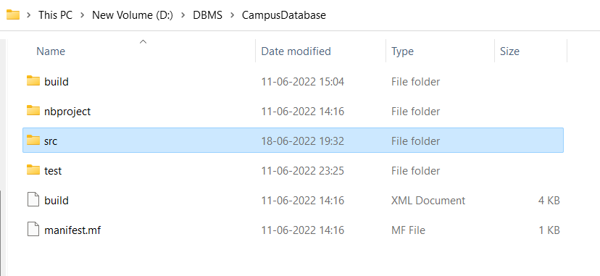

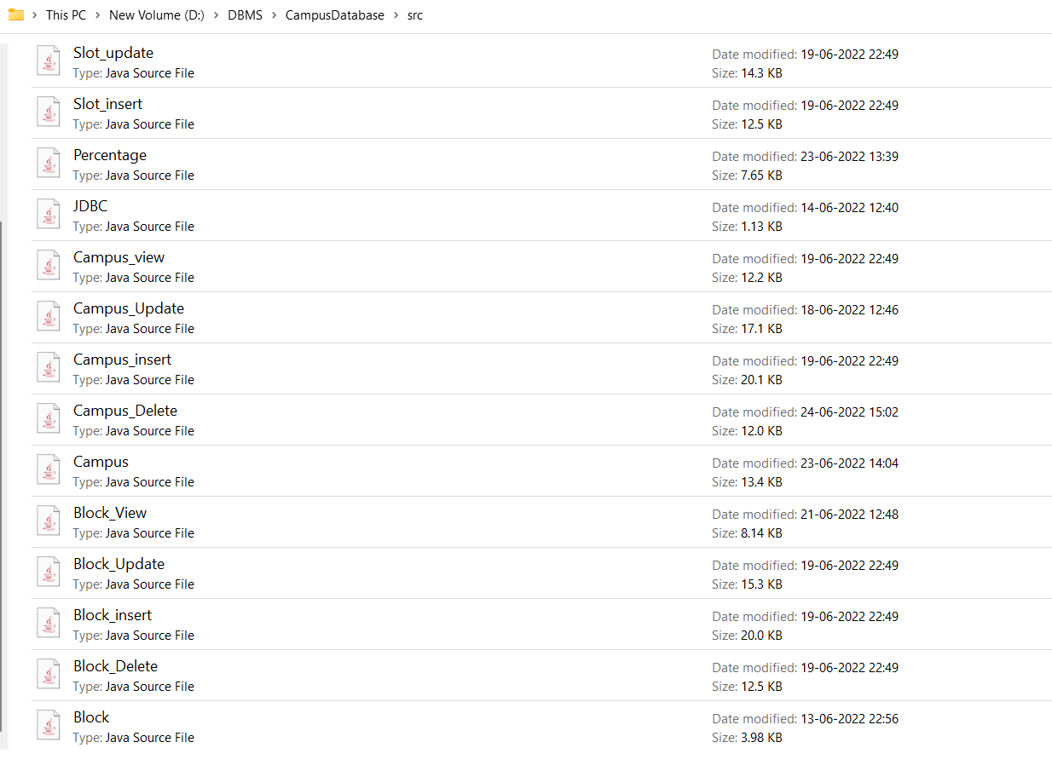

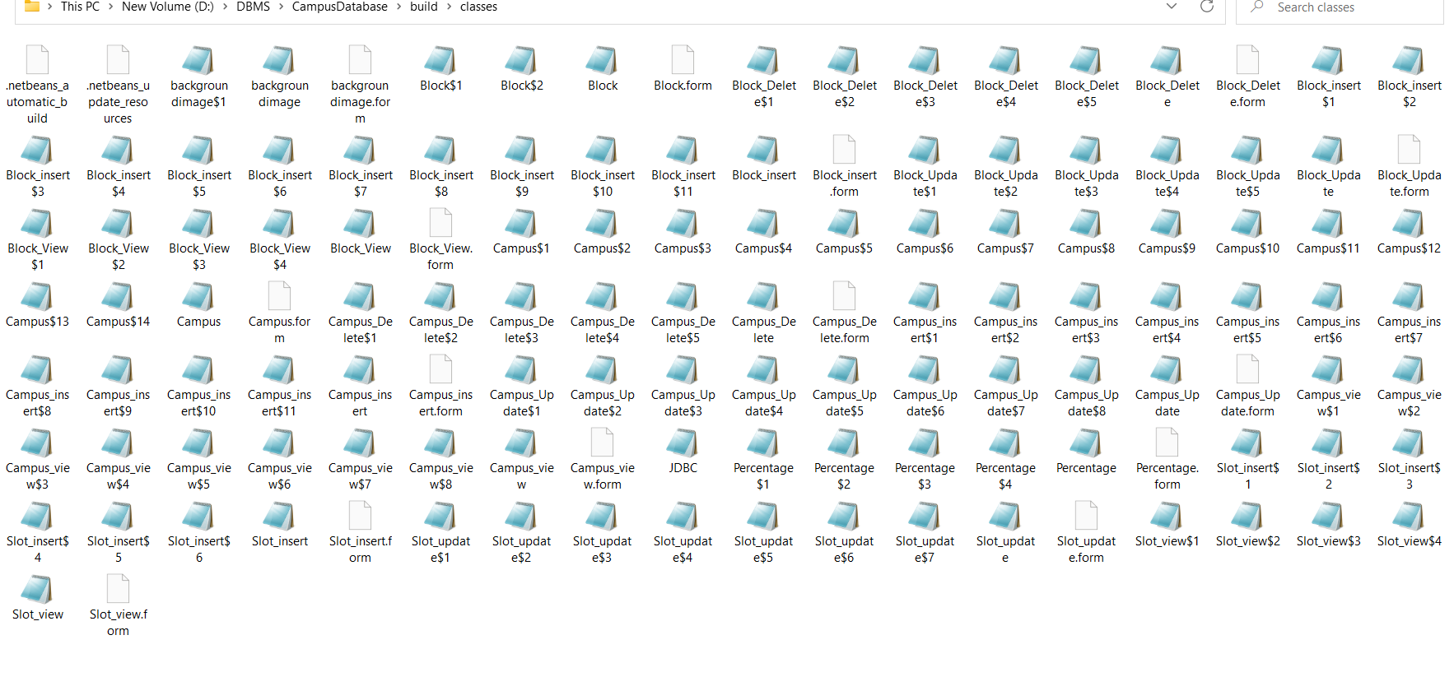**Testing:**

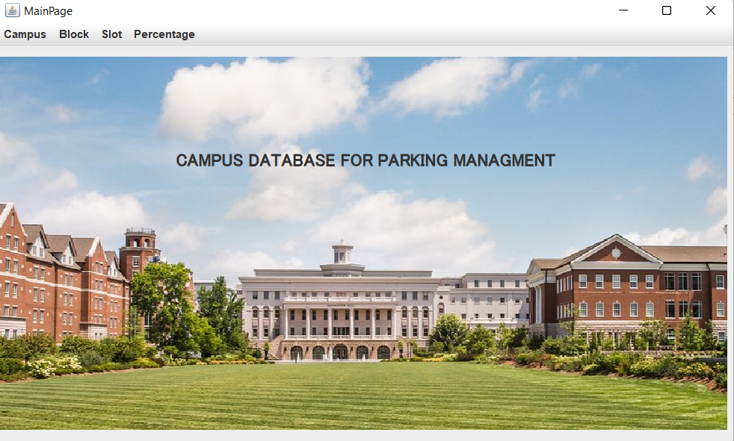

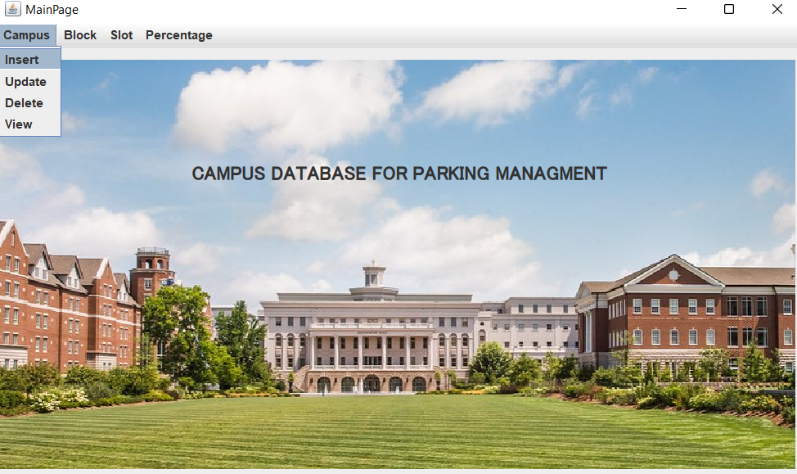

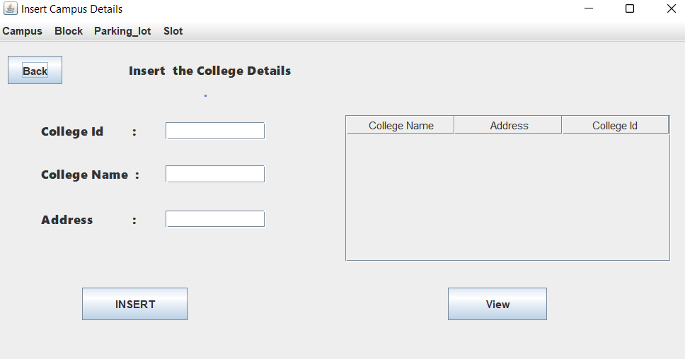

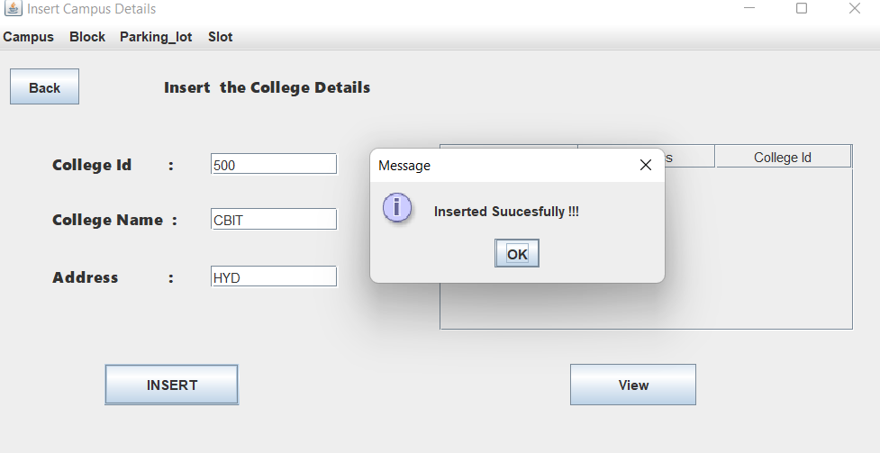

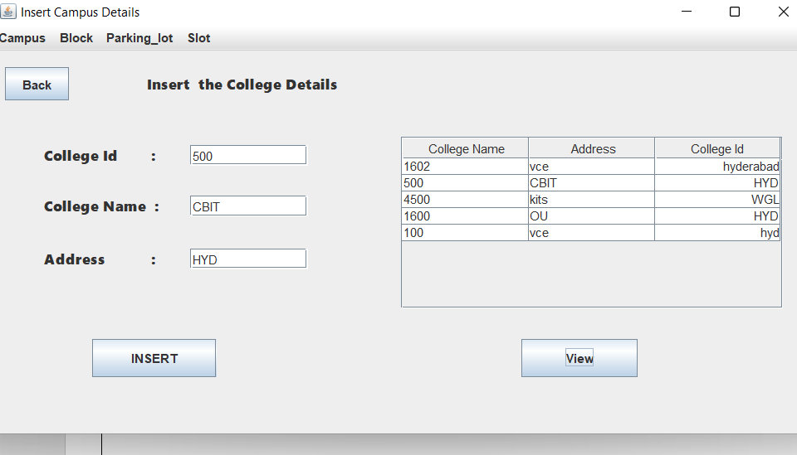

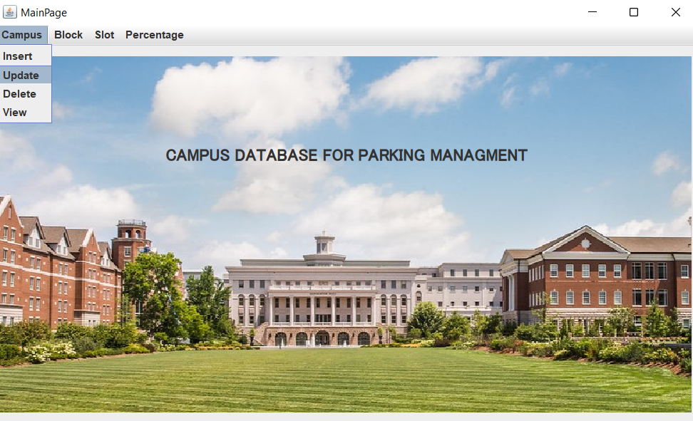

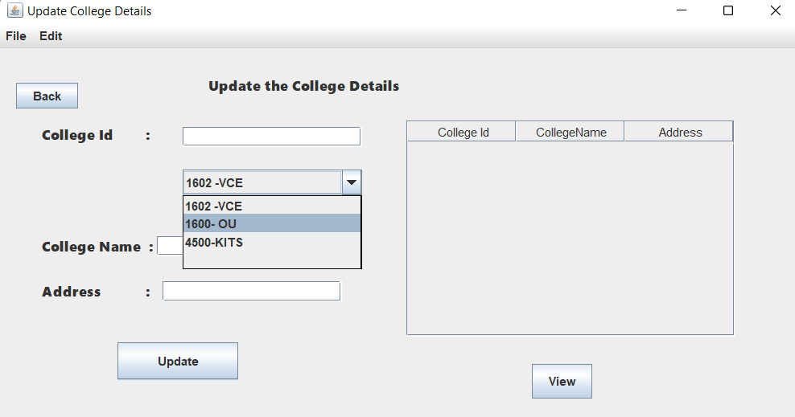

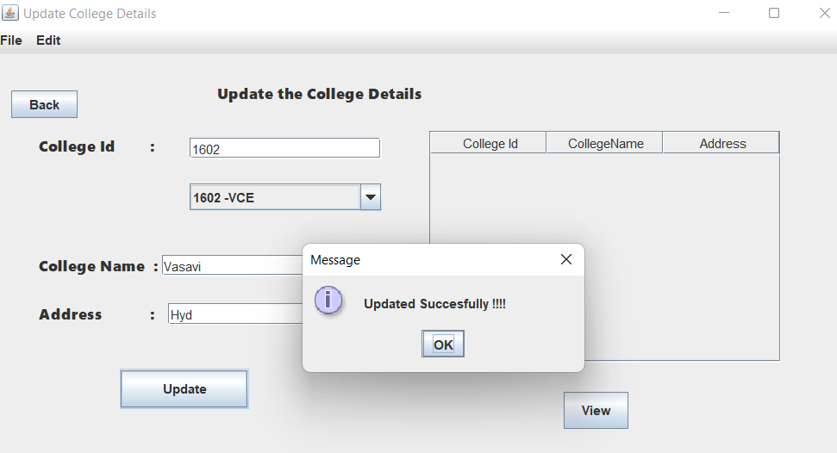

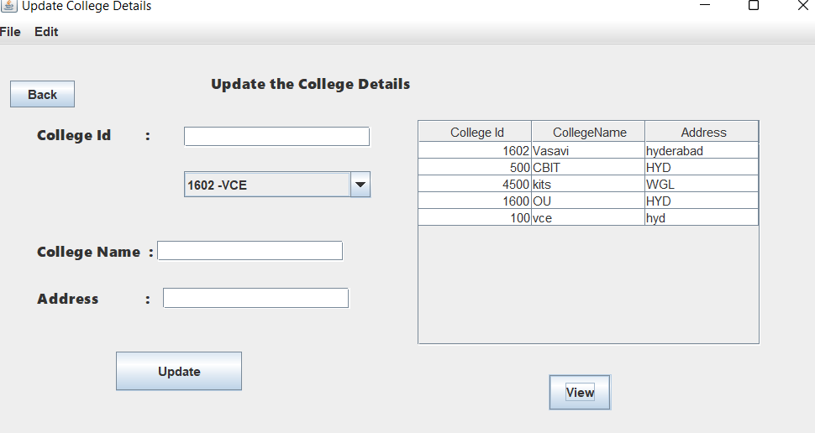

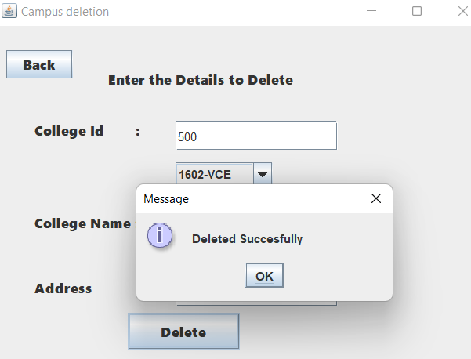

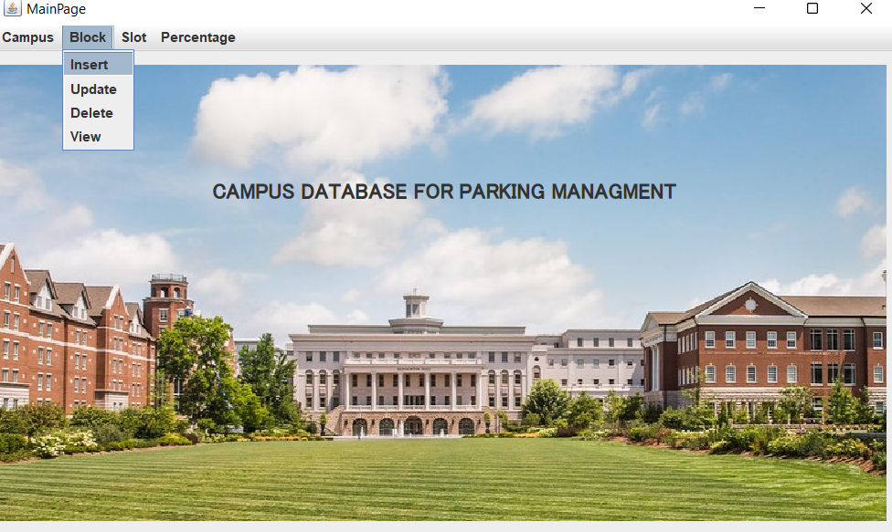

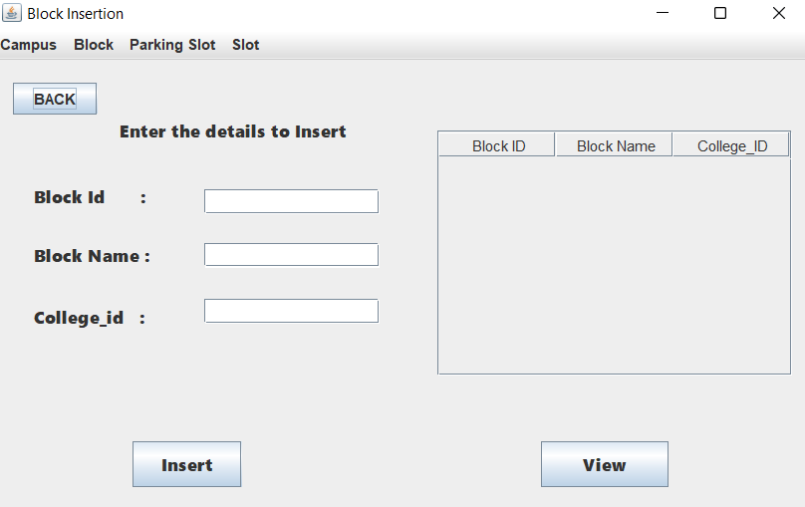

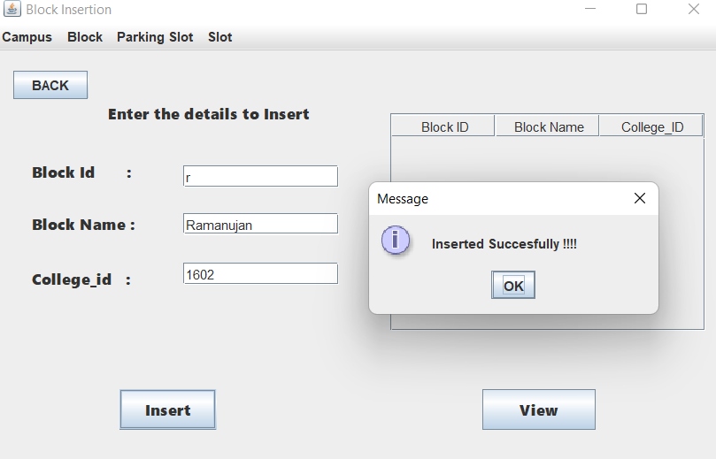

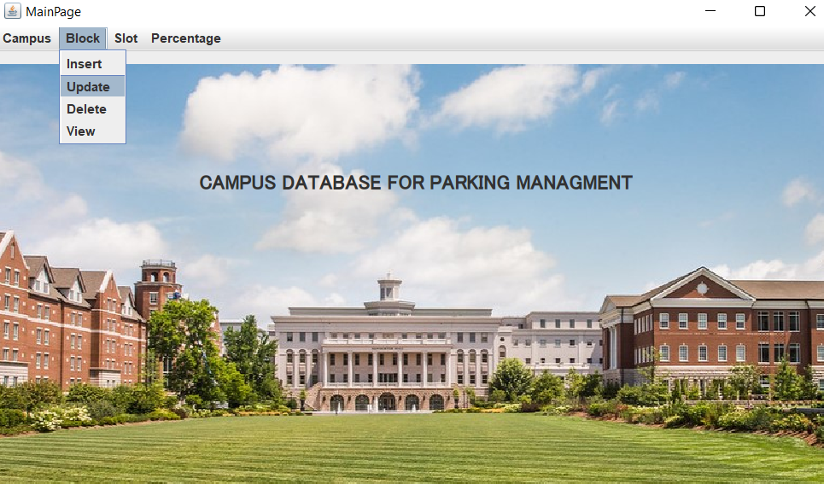

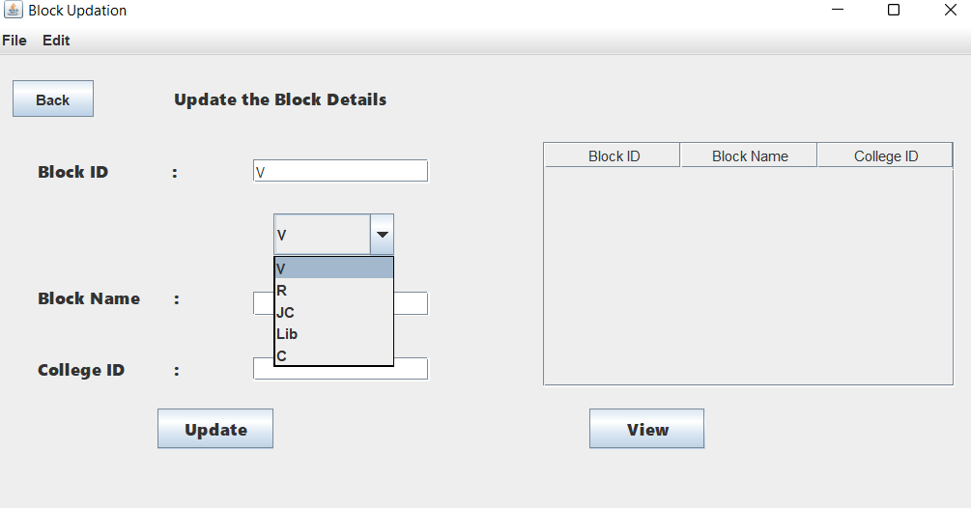

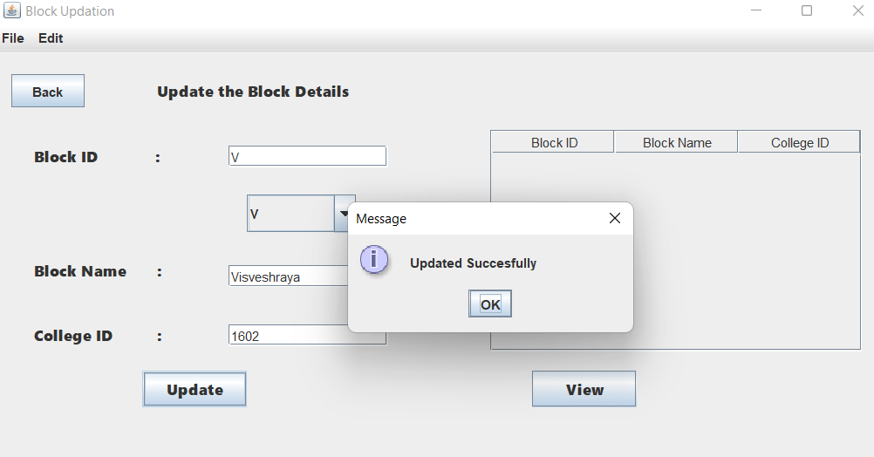

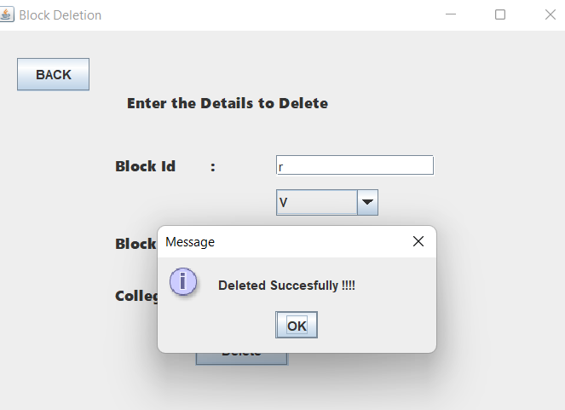

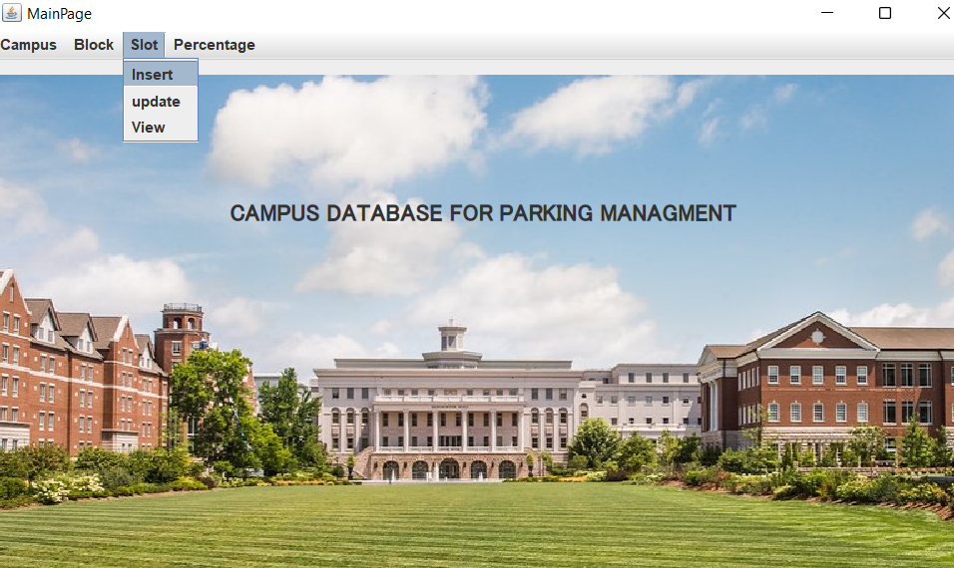

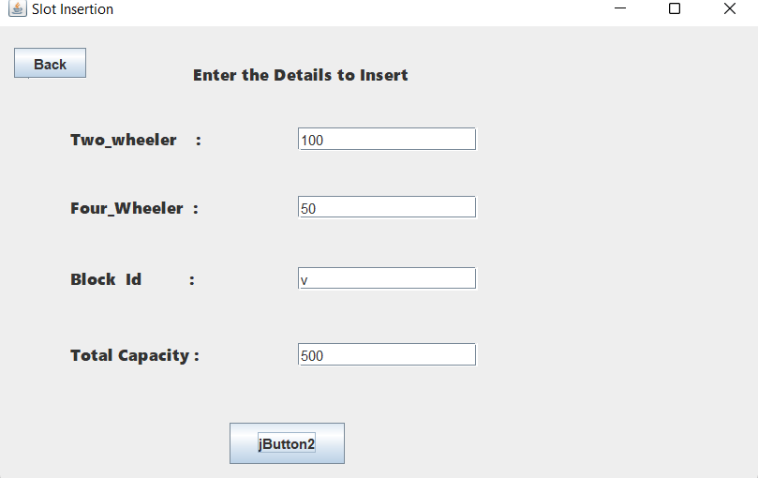

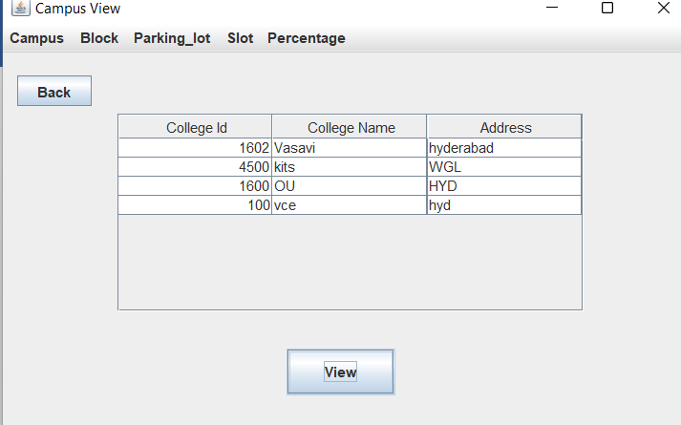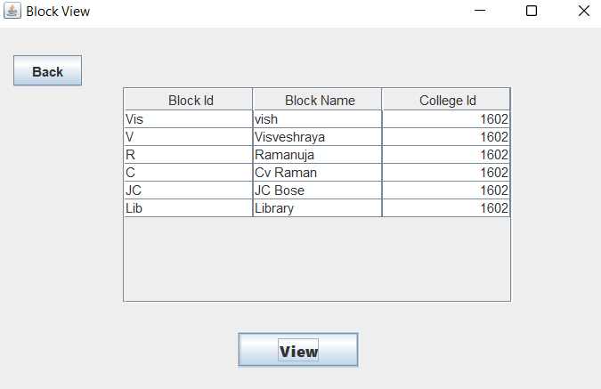

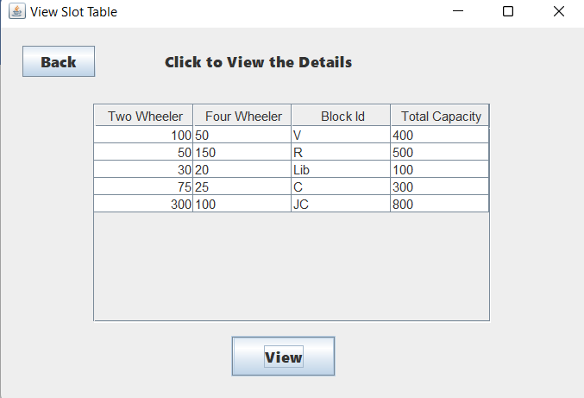

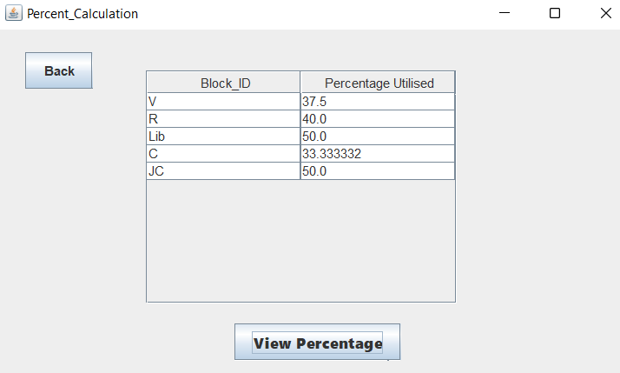

**Results:** I had successfully completed PROJECT on “CAMPUS DATABASE FOR PARKING MANAGMENT”.

**Discussion and future Work:**

This application provides the students /faculty to know about the information of parking capacity in the campus per block. In this application, it stores the information about the campus details, block details and parking lot details.

I also wanted this application can provide the interface for student/faculty be able to book their slot in the parking lot and able to view no of slots left over for parking.

**CONCLUSION:**

Thus, a Java SWING based ***CAMPUS DATABASE FOR PARKING MANAGEMENT*** is created which is connected to the Oracle 11g database. Therefore, all the entries and details are directly updated on their respective tables created in the database